Test Bank - Chapter 3
The questions in the test bank cover the concepts from the lessons in Chapter 3. Select questions from any of the categories that match the content you covered with students. The types of questions include multiple choice, true/false, fill-in-the-blank, and short answer.

Multiple Choice

- The density of an object is
  - The mass divided by the volume D = m/v
  - The volume divided by the mass D = v/m
  - The same as its weight
  - The same as the size of the object

- If two objects have the same volume but one has a greater mass, the one with greater mass
  - Has a lower density
  - Has a higher density
  - Will float
  - Will sink

- If two objects have the same volume but one is made up of smaller and heavier atoms, the one with small heavy atoms will
  - Be larger than the other
  - Be less dense than the other
  - Be more dense than the other
  - Float

- If you cut a wooden block in half, each half would have
  - Half the density of the original piece
  - Twice the density of the original piece
  - The same density as the original piece
  - No density at all

- In the water displacement method for finding volume
  - You subtract the final volume from the initial volume
  - You subtract the initial volume from the final volume
  - You add the initial and final volumes
  - You divide the final volume by 2

- If two objects have the same mass but different volumes
  - The one with the larger volume has the lower density
  - They must have the same density
  - The one with the larger volume has the higher density
  - The one with the larger volume is twice as dense

- If the density of water is 1 gram/cm³, this means that the mass of 100 cm³ of water should be
  - 100 grams
  - 50 grams
  - 1000 grams
  - 1 gram

- Density is a characteristic property of a substance. This means that the density of water
  - Changes depending on the volume
  - Stays the same regardless of the volume
  - Is greater for a greater mass of water
  - Is less for a smaller mass of water

- 100 milliliters of water has a mass of 100 grams. If you measured the mass of 50 milliliters of water, the mass would be
  - 25 grams
  - 200 grams
  - 100 grams
  - 50 grams

- To find the mass of water in a graduated cylinder, you could
  - Take the total mass of the water and graduated cylinder and subtract the mass of the water
  - Take the total mass of the water and graduated cylinder and subtract the mass of the graduated cylinder
  - Add the mass of the water to the mass of the graduated cylinder
  - Take the total mass of the water and graduated cylinder and divide the mass by two

- An object should float in a liquid if it is
  - More dense than the liquid
  - Less dense than the liquid
  - Lighter than metal
  - Shaped like a ball

- A tiny piece of sand is very light but sinks in water. This is because
  - Sand is a solid
  - Sand is less dense than water
  - There is more water than sand
  - Sand is more dense than water

- Wood floats in water. If you measured the mass of the same volume of wood and water
  - The water would have a greater mass
  - The water would have a lower mass
  - The mass of the wood and water would be the same
  - The mass of the wood and water would both be 100 grams

- A candle floats in water but sinks in alcohol. This is because
  - The candle has less mass in alcohol
  - The water has less mass than the alcohol
  - The water is more dense than the alcohol
  - Water and alcohol are both liquids

- Alcohol is less dense than water. If you measured the mass of the same volume of alcohol and water
  - The water would have a greater mass
  - The water would have a lower mass
  - The mass of the alcohol and water would be the same
  - The mass of the alcohol and water would cancel each other out

- A carrot floats in salt water but sinks in fresh water. This is because
  - Salt water is more dense than fresh water
  - Fresh water is more dense than salt water
  - The carrot is more dense than salt water
  - A larger piece of carrot has a different density

- The density of hot water
  - Is greater than the density of cold water
  - Is less than the density of cold water
  - The same as the density of cold water
  - Depends on the volume of water

- The density of hot and cold water are different mainly because
  - The molecules in hot water move slower and are slightly closer together
  - The molecules in hot water are larger
  - The molecules in hot water move faster and are slightly further apart
  - The molecules in cold water move faster and are further apart

Chapter 3
Multiple Choice Answers

- a  - b  - c  - c  - b  - a  - a  - b  - d | - b  - b  - d  - a  - c  - a  - a  - b  - c

True/False and Fill-in-the-blank

The mass of atoms, their size, and how they are arranged determine the ____of a substance. density

True or false?
The relationship between mass and volume in density can be expressed as
D = mv² False

True or false?
A submerged object displaces a volume of liquid equal to the volume of the object. True

The of atoms, their size, and how they are ___determine the density of a substance. mass, arranged

In a laboratory, the volume of a liquid is usually measured with a cylinder. graduated

True or false?
If you have two samples of the same substance, but one sample is larger than the other, the larger sample will have a greater density. False

Hot water is dense than cold water because the molecules in hot water are
apart. less, farther

True or false?
A liquid will float if it is more dense than the liquid it is placed in. False

The of an object and the _______ of a liquid determines whether the object will float or sink in the liquid substance. density, density

True or false?
Temperature affects the density of a substance. True

Cooling a substance causes its molecules to slow down and get slightly closer together, occupying a smaller ______that results in an increase in density. volume

Short Answer

What is the mathematical equation for density? Density = mass/volume or D=m/v

Think about the formula for density: Density = mass/volume and explain why density is measured in the units: g/cm³.
Mass is measured in grams, and volume is measured in cm³.

If two substances A and B have the same volume, but substance A has greater mass, which one will have the greater density?
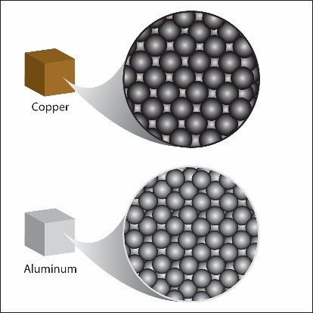
Substance A because if density = m/v, and Substance A has more mass, this would make its density greater.

Imagine that you have a cube of copper and a cube of aluminum which are exactly the same size and shape. When you place them each on an electronic balance, you find that the copper cube has more mass than the aluminum cube. Give one possible reason why the copper cube has more mass.
Copper atoms each have a greater mass than aluminum atoms.
or
Copper atoms are smaller so that more of them can fit in the cube.
or
Copper atoms are arranged closer together so that there are more atoms in the cube.

Glass jars are much more dense than plastic jars. What can you guess about the mass, size, and arrangement of the molecules that make up glass compared to the molecules that make up plastics?
Glass could have smaller more massive atoms that are close together which would give glass a higher density.

In addition to their arrangement, what are two other properties of atoms that can affect density?
The size of the atoms and their mass can also affect density.

Pretend that you have two substances. Substance A is made up entirely of one kind of atom. Substance B is made up entirely of another kind of atom. If the atoms that make up substance B are smaller and less massive than the atoms that make up substance A, is it possible for substance B to have a greater density? Why?
Yes it is possible. Even though the atoms are less massive, if they are small enough, there may be so many atoms in a volume of substance B that the overall mass compared to the volume (density) is actually greater than substance A.

Describe the steps of the water displacement method for finding the volume of a sample.
First you put water in a graduated cylinder and check the initial volume. Then you place the sample all the way into the water and see the final level where the water is. Then you subtract the initial volume from the final volume. This will give you the volume of the sample.

What is the volume of an object that made the water level rise in a graduated cylinder from 50 mL to 59 mL? Remember that volume is measured in cm³ and not mL when giving your answer. The volume of the object would be 9 cm³.

When using the water displacement method, you were instructed to push the cylinder that floated down so that it was just beneath the surface of the water. What would you measure if you let the cylinder float when you looked at the water level in the graduated cylinder?
If you left the object floating, you would be finding the volume of only of the part that was under water. Because you want the volume of the entire cylinder, you have to make sure that the entire cylinder goes under the water.

Will different volumes of water always have the same density? Why or why not?
They should if their temperatures are the same. The amount of water doesn’t matter but the temperature does.

How can you use a graduated cylinder, water, and an electronic balance to find the density of water?
I would use a graduated cylinder to measure a certain amount of water in mL. Then I would use the balance to measure the mass of this amount of water in grams. Because 1 mL is the same as 1 cm³, the density is the number of grams divided by the number of mL of water.

What is the density of water? The density of water is 1 g/cm³.

What does it mean that density is a “characteristic property” of a substance?
This means that any sample of the substance should have the same density. It doesn’t matter whether it is a large or small sample. They should all have the same density.

How can you use the density of an unknown substance to identify it?
Once you know the density of the unknown substance, you would compare that to the density of known substances.
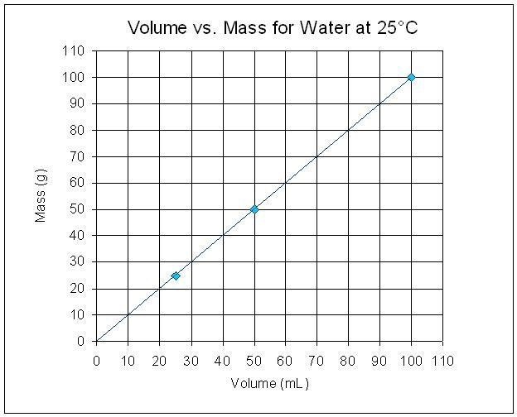

Look at the graph to help you answer the question. What would you expect the mass of 500 mL of water to be? Why?
Looking at the chart, the volume of water in mL is always the same as the mass of water in grams. So the mass of 500 mL of water will be 500 g.

Explain, on the molecular level, why a candle floats in water.
A candle floats because it is less dense than water. It is less dense because the molecules that make up wax are made from atoms which are a little bit less massive than the atoms that make up water and they are not packed as tightly together as water molecules.

Look at the drawings below and think about the size, mass, or arrangement of water molecules compared to the molecules of wax. Why does a candle float on water?
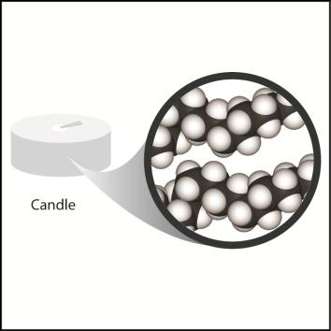
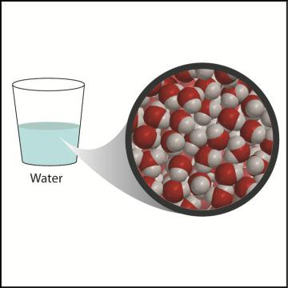

Water molecules and wax molecules both have hydrogen atoms but water has oxygen atoms, and wax has carbon atoms. Oxygen is a little smaller than carbon and also heavier. Water molecules are also packed closer together than the molecules of wax. All this makes water more dense than wax.

A piece of ice floats on water. What does this tell you about the density of ice compared to the density of water?
Ice is less dense than water.

A solid piece of candle wax sinks in melted wax. What does this tell you about the density of a solid piece of candle compared to the density of melted wax?
A solid piece of candle wax is more dense than melted wax.

Will an object with a density of 0.86 g/cm³ sink or float in water? How do you know?
It will float because its density is less than the density of water, which is 1 g/cm³.
How does dissolving salt in water change the density of the water?
Dissolving salt in water adds mass to the water but does not increase the volume very much. Since D=m/v, if mass increases more than volume, the density will increase.

How would you expect water, isopropyl alcohol, and saltwater to layer if you poured them into a cup?
Top: Isopropyl alcohol
Middle: Water
Bottom: Saltwater
How could you use a graduated cylinder and balance to find out which is more dense, saltwater or isopropyl alcohol?
I would measure 20 mL of each solution in a graduated cylinder. Then I would place each graduated cylinder on a balance. The one that has more mass is the most dense.

Explain, on the molecular level, how hot water can float on room-temperature water.
In hot water, the water molecules move faster and get a little further apart. Therefore, the same mass of water has a slightly larger volume. Since D=m/v, a larger volume means a lower density. Therefore, hot water is less dense than room temperature water and can float on it.

Briefly explain how cooling water affects its density.
Cooling water causes the molecules to slow down and their attractions to bring them closer together. This makes the same mass of water take up slightly less volume. Since D=m/v, a smaller volume means a higher density. Therefore, cold water is more dense than room temperature water and will sink in it.

This is true until water begins to freeze. When it freezes, water molecules move further apart than in liquid water. This makes ice less dense than water causing it to float.

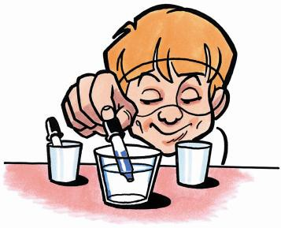
You put cold water colored blue into room temperature water. The cold water sank in the room temperature water. Use what you know about the motion and attraction of molecules and density to explain why this happened.
Since the water was colder, the water molecules were moving slower, so their attractions brought them closer together. Since the molecules were closer together, there is more mass per volume of water. This makes the water more dense than room temperature water so the cold water sinks.

It might seem strange but hot water and ice both float on room temperature water. Explain why this happens.
In hot water, the molecules move faster. This motion competes with their attractions, and they move a little further apart. This means that there is less mass per volume of water. This makes the water less dense than room temperature water so the hot water floats.

In ice, the water molecules are actually further apart than they are in room temperature water. This makes ice less dense than water so ice floats.

Refer to the diagram below to explain why hot water will float on cold water?
The molecules in hot water are slightly further apart than in cold water. This increases the volume slightly while the mass stays the same. This makes hot water less dense, so it floats on the more-dense cold water.
