Chapter 3, Lesson 3: Density of Water
Key Concepts
- Just like solids, liquids also have their own characteristic density.
- The volume of a liquid can be measured directly with a graduated cylinder.
- The molecules of different liquids have different size and mass.
- The mass and size of the molecules in a liquid and how closely they are packed together determine the density of the liquid.
- Just like a solid, the density of a liquid equals the mass of the liquid divided by its volume; D = m/v.
- The density of water is 1 gram per cubic centimeter.
- The density of a substance is the same regardless of the size of the sample.
Summary
Students measure the volume and mass of water to determine its density. Then they measure the mass of different volumes of water and discover that the density is always the same. Students make a graph of the relationship between the volume and the mass of water.
Objective
Students will be able to measure the volume and mass of water and calculate its density. Students will be able to explain that since any volume of water always has the same density, at a given temperature, that density is a characteristic property of water.
Evaluation
The activity sheet will serve as the “Evaluate” component of each 5-E lesson plan. The activity sheets are formative assessments of student progress and understanding. A more formal summative assessment is included at the end of each chapter.
Safety
Make sure you and your students wear properly fitting goggles.

Materials for Each Group
- Graduated cylinder, 100 ml
- Water
- Balance that measures in grams (able to measure over 100 g)
- Dropper
Materials for the Demonstration
- Water
- Two identical buckets or large containers

ENGAGE

Do a demonstration to introduce the idea that water has density.
Materials
  - Water
  - Two identical buckets or large containers

Teacher preparation
  - Half-fill one bucket and add only about 1 cup of water to the other.

Procedure
- Select a student to lift both buckets of water.
- Ask the student volunteer which bucket appears to have more mass.

Expected results
The bucket containing more water has more mass.
Ask students:

In Lessons 1 and 2, you found the density of solids, by measuring their mass and volume. Do you think a liquid, like water can have a density?
Students should realize that water has volume and mass. Because D=m/v, water must also have density.

How do you think you can find the density of a liquid like water?
Students are not expected to be able to fully answer this question at this point. It is meant as a lead-in to the investigation. But students may realize that they should somehow find the mass and volume of the water.

Could both the small and large amounts of water your classmate lifted have the same density?
Students may point out that the bucket with more water has more mass but a greater volume. The bucket with less mass has less volume. So it is possible that different amounts of water could have the same density.

Give each student an activity sheet.
Students will record their observations and answer questions about the activity on the activity sheet. The Explain It with Atoms and Molecules and Take It Further sections of the activity sheet will either be completed as a class, in groups, or individually depending on your instructions. Look at the teacher version of the activity sheet to find the questions and answers.

EXPLORE

Discuss with students how to find the volume and mass of water.
Tell students that they are going to try to find the density of water.

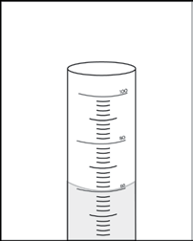
Ask students:

What two things do you need to know in order to find the density of water?
Students should realize that they need both the volume and mass of a sample of water to find its density.

How can you measure a volume of water?
Suggest that students use a graduated cylinder to measure volume in milliliters. Remind students that each milliliter equals 1 cm³.

How can you measure the mass of water?
Suggest that students use a balance to measure the mass in grams. Tell students that they can find mass by weighing the water. However, since water is a liquid, it needs to be in some sort of container. So in order to weigh the water, they have to weigh the container, too. Explain to students that they will have to subtract the mass of an empty graduated cylinder from the mass of the cylinder and water to get the mass of just the water.
Measuring the mass of water
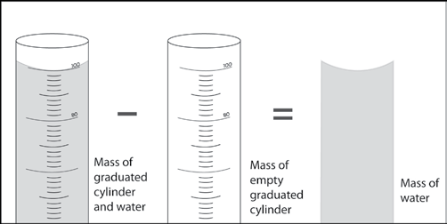

Have students find the mass of different volumes of water to show that the density of water does not depend on the size of the sample.
Question to investigate
Do different amounts of water have the same density?

Materials for each group
  - Graduated cylinder, 100 ml
  - Water
  - Balance that measures in grams (able to measure over 100 g)
  - Dropper

Procedure
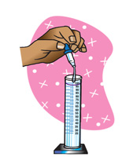
- Find the mass of an empty graduated cylinder. Record the mass in grams in the chart on the activity sheet.
- Pour 100 mL of water into the graduated cylinder. Try to be as accurate as possible by checking that the meniscus is right at the 100-mL mark. Use a dropper to add or remove small amounts of water.
- Weigh the graduated cylinder with the water in it. Record the mass in grams.
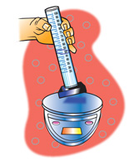
- Find the mass of only the water by subtracting the mass of the empty graduated cylinder. Record the mass of 100 mL of water in the chart.
- Use the mass and volume of the water to calculate density. Record the density in g/cm³ in the chart.
- Pour off water until you have 50 mL of water in the graduated cylinder. If you accidentally pour out a little too much, add water until you get as close as you can to 50 mL.
- Find the mass of 50 mL of water. Record the mass in the activity sheet. Calculate and record the density.
- Next, pour off water until you have 25 mL of water in the graduated
cylinder. Find the mass of 25 mL of water and record it in the chart. Calculate and record the density.

Finding the density of different volumes of water
Volume of water | 100 milliliters | 50 milliliters | 25 milliliters
Mass of graduated cylinder + water (g)
Mass of empty graduated cylinder (g)
Mass of water (g)
Density of water (g/cm³)

Expected results
The density of water should be close to 1 g/cm³. This is true for 100, 50, or 25 mL.

Ask students:

Look at your values for density in your chart. Does the density of the different volumes of water seem to be about the same?
Help students see that most of the different values for density are near 1 g/cm³. They may wonder why their values are not all exactly 1 g/cm³. One reason could be inaccuracies in measuring. Another reason is that the density of water changes with temperature. Water is most dense at 4 °C and at that temperature has a density of 1 g/cm³. At room temperature, around 20–25 °C, the density is about 0.99 g/cm³.

What is the density of water in g/cm³?
Students’ answers will vary, but their values should mostly be around 1 g/cm³.

Have students graph their results.
Help students make a graph of the data on their activity sheet. The x-axis should be volume and the y-axis should be mass.
When students plot their data, there should be a straight line showing that as volume increases, mass increases by the same amount.

Volume vs. Mass for Water at Room Temperature
110
100
90
80
70
60
50
40
30
20
10
0
0 10 20 30 40 50 60 70 80 90 100 110
Volume (mL)

Mass (g)

Discuss student observations, data, and graphs.
Ask students:

Use your graph to find the mass of 40 mL of water. What is the density of this volume of water?
The mass of 40 mL of water is 40 grams. Since D = m/v and mL = cm³, the density of water is 1 g/cm³.

Choose a volume between 1 and 100 mL. Use your graph to find the mass. What is the density of this volume of water?
Whether students weigh 100, 50, 25 mL or any other amount, the density of water will always be 1 g/cm³.

Tell students that density is a characteristic property of a substance. This means that the density of a substance is the same regardless of the size of the sample.

Ask students:

Is density a characteristic property of water? How do you know?
Density is a characteristic property of water because the density of any sample of water (at the same temperature) is always the same. The density is 1 g/cm³.

EXPLAIN

Explain why the density of any size sample of water is always the same.
Project the image Density of Water. www.acs.org/middleschoolchemistry/simulations/chapter3/lesson3.html
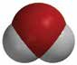
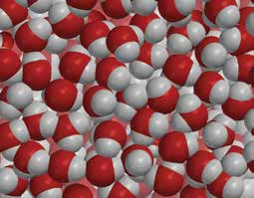
Water molecules all have the same
mass and size. Water molecules are also packed pretty close together. They are packed the same way throughout an entire sample of water. So, if a volume of water has a certain mass, twice the volume will have twice the mass, three times the volume has three times the mass, etc. No matter what size sample of water you measure, the relationship between the mass and volume will always be the same. Because D=m/v, the density is the same for any amount of water.

Project the animation Liquid Water.
www.acs.org/middleschoolchemistry/simulations/chapter3/lesson3.html
Water molecules are always moving. But on average they are packed the same throughout. Therefore, the ratio between the mass and volume is the same, making the density the same. This is true no matter the size of the sample or where you select your sample from.

EXTEND

Have students consider whether the density of a large piece of a solid substance is the same as the density of a smaller piece.
Give students time to calculate the density of each of the three samples drawn on their activity sheet and answer the related questions.

Ask students:

The density of a liquid is the same no matter what the size of the sample. Could this be true for solids, too? Calculate the density of each of the three samples to find out.
Yes. The density of a solid substance is the same no matter how big or small the sample.

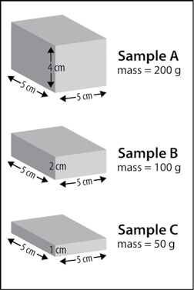
Sample A has a mass of 200 g. What is the density of Sample A?
D = m/v
D = 200g/100cm³
D = 2 g/cm³

If you cut Sample A in half and looked at only one half, you would have Sample B. What is the density of Sample B?
If students do not know what the mass
is, tell them that it is half the mass of Sample A. Because Sample A was 200 g, Sample B is one half the volume and therefore one half the mass (100 g).
D = m/v
D = 100g/50cm³ D = 2 g/cm³

If you cut Sample B in half, you would
have Sample C. What is the density of Sample C?
D = m/v
D = 50g/25cm³ D = 2 g/cm³

