Chapter 5—Student Reading
THE POLARITY OF THE WATER MOLECULE

Wonderful water

Water is an amazing substance. We drink it, cook and wash with it, swim and play in it, and use it for lots of other purposes. The water in our bodies helps keep us cool and the water in the oceans helps regulate the temperature and weather on Earth.
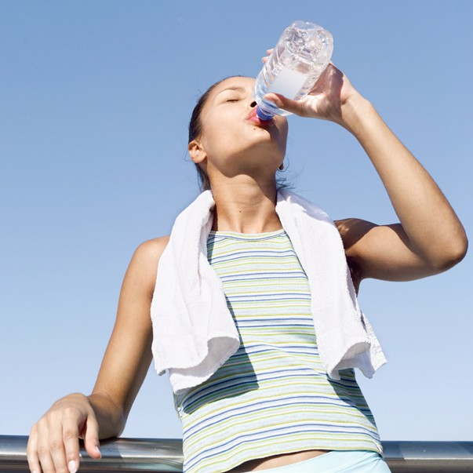

To understand what makes water so special, you need to look at the atoms that a water molecule is made from and how these atoms are bonded together. After you understand the characteristics of a single water molecule, it is easier to see why many water molecules together make water act the way it does.

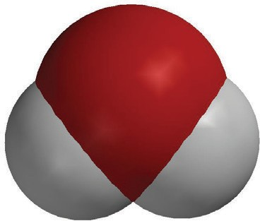
A molecular view of water

You already know that a water molecule is made up of two hydrogen atoms bonded to one oxygen atom. That’s why the chemical formula for water is H₂O.
The hydrogen atoms and oxygen atom are bonded by covalent bonds. In a covalent bond, an electron from each atom is attracted to the protons of the other atom. If the attraction is strong enough in both directions and there is room for the electron in the outer energy level, the electrons end up being attracted and shared by both atoms.
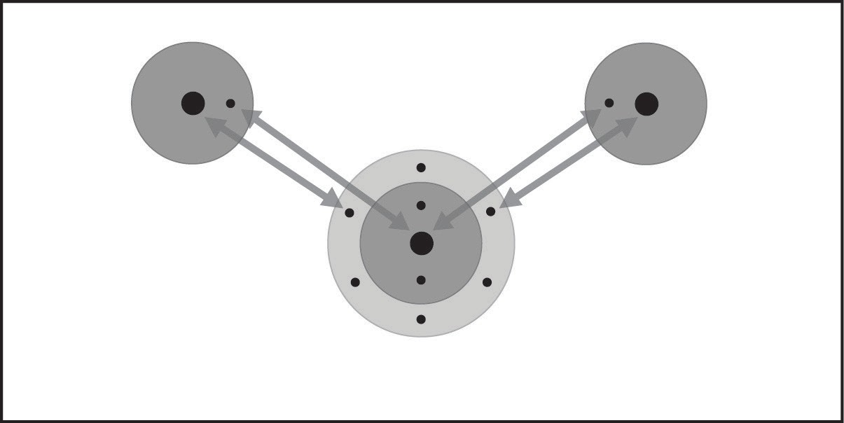
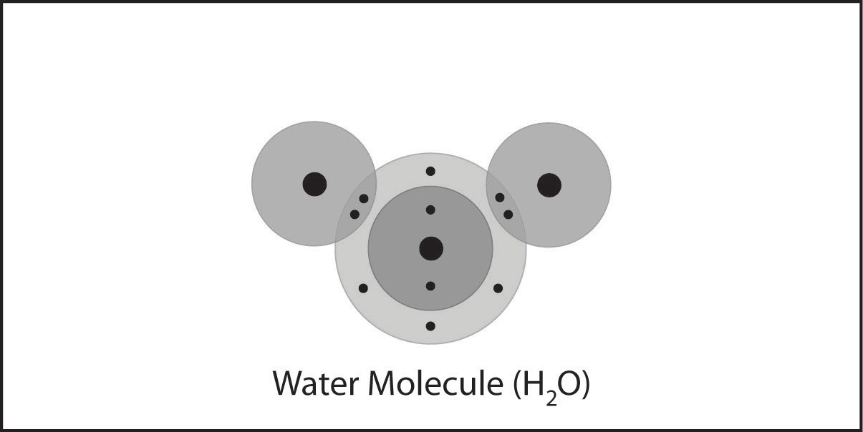

Water is a polar molecule
Even though electrons are shared in the covalent bonds in a water molecule, the electrons are not shared equally. The oxygen atom has a stronger attraction for electrons than the hydrogen atoms. Therefore, the electrons tend to spend a little more time at the oxygen end of the molecule than at the hydrogen end. Since electrons are negative, this makes the oxygen end a bit negative. Since the electrons are not at the hydrogen end of the molecule as much, the hydrogen end is a bit positive.
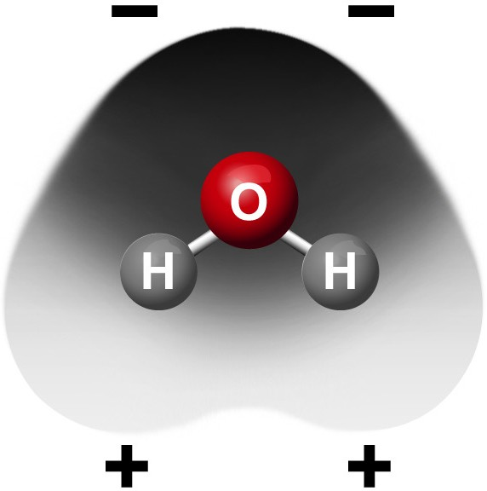
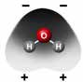
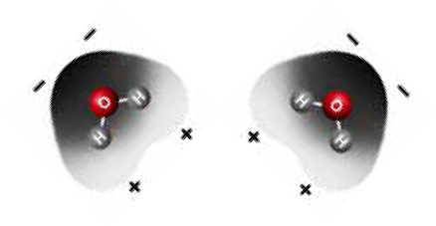

The water molecule hasn’t gained or lost any electrons, but the electrons are just spending more time in one area of the molecule than another. When electrons do this in a molecule, it is called a polar molecule. The positive and negative polar areas of the water molecule attract each other. This gives water many of its characteristic properties.

Polar molecules and evaporation

The polar characteristics of molecules of a liquid can affect how quickly the liquid evaporates. For instance, alcohol molecules evaporate at a faster rate than water molecules. One reason for this is that the attraction between alcohol molecules is not as strong as the attraction between water molecules.

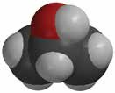
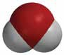
–
+
–
–
+
+

Look at the models of the water and alcohol molecules. Water has two oxygen-hydrogen (O–H) bonds which are pretty polar. Alcohol only has one O–H bond and a few carbon-hydrogen (C–H) bonds which are not very polar. Because of this difference in polarity, the attraction between alcohol molecules is not as strong as the attraction between water molecules. This allows alcohol to evaporate more quickly than water.

Water’s surface tension
You have probably seen drops of water “bead up” on a piece of wax paper or on a newly waxed car or other clean hard surface. The strong attraction that water molecules have for each other also helps explain why water beads up the way it does. Inside a drop of water, the water molecules are being attracted in every direction.

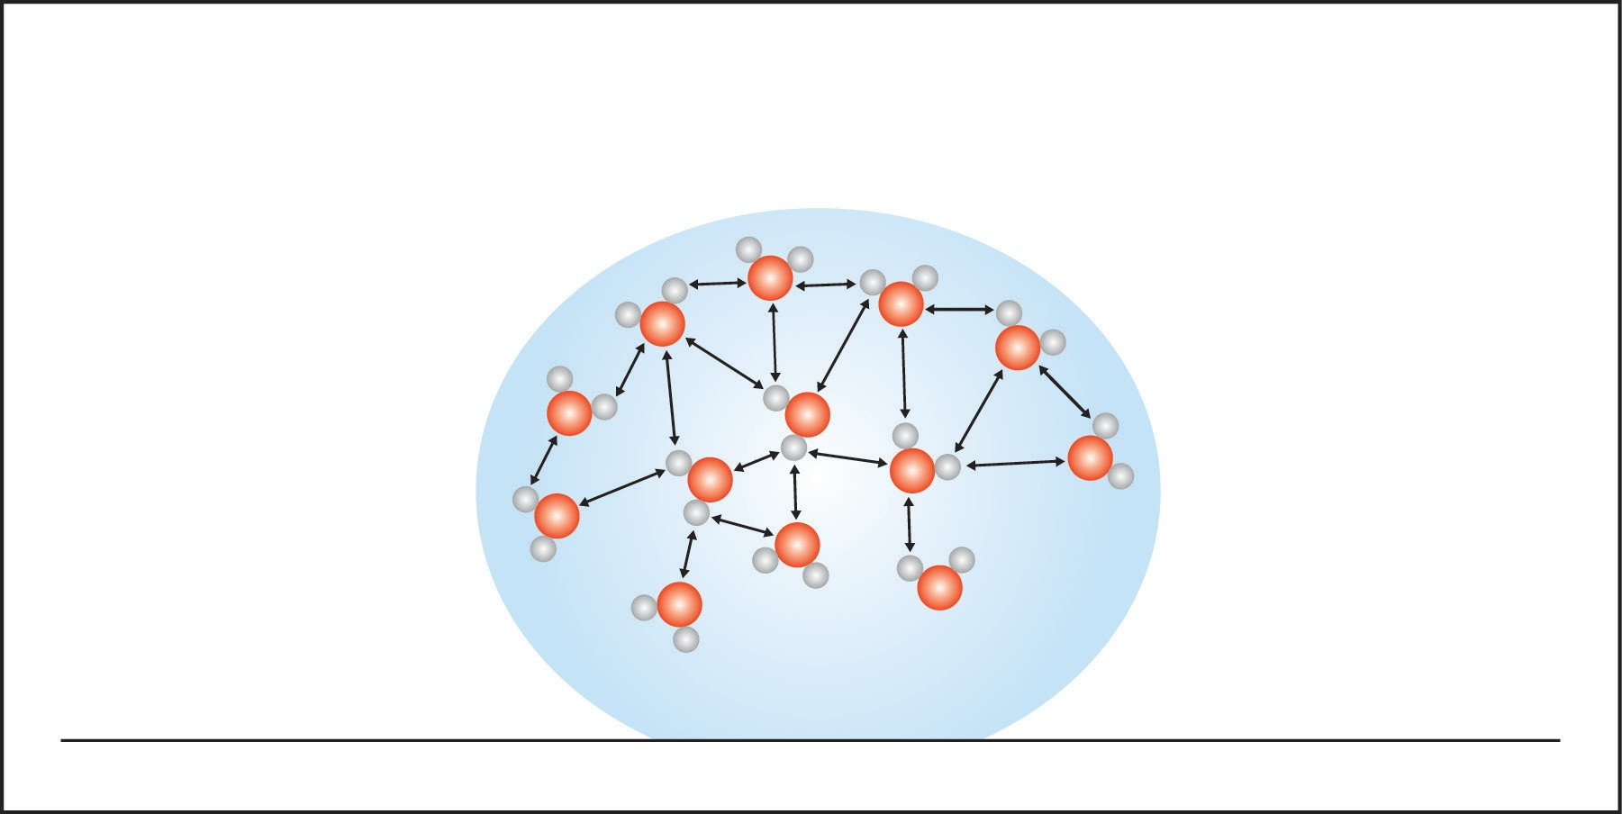

But the molecules at the surface only feel attractions from the molecules next to them and beneath them because there are no liquid water molecules above them. These surface molecules are pulled together and inward by these attractions. This inward pull results in a tight arrangement of molecules over the water’s surface. This tight arrangement at the surface is called surface tension. The inward pull from the attractions of the molecules results in the smallest possible surface for a volume of water, which is a sphere.

Why water dissolves salt
A sodium chloride crystal is made up of positively charged sodium ions and negatively charged chloride ions. The positive and negative ends of the polar water molecules can arrange themselves near an ion and help remove it from the crystal. The positive area of a water molecule is attracted to the negative chloride ion. The negative area of a water molecule is attracted to the positive sodium ion.
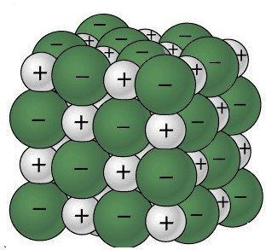
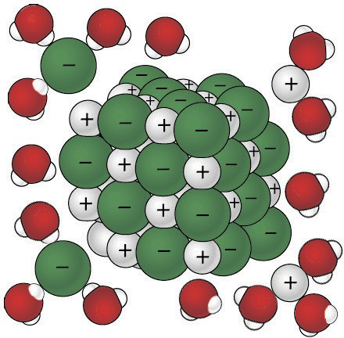
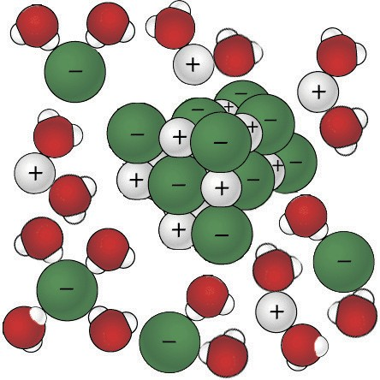
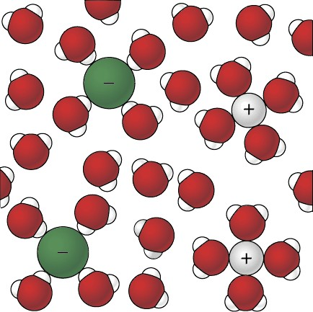

Dissolving happens when the attractions between the water molecules and the sodium and chloride ions overcome the attractions of the ions to each other. This causes the ions to separate from one another and become thoroughly mixed into the water.
Mixtures and solutions
When talking about dissolving, the substance being dissolved is called the solute. The substance doing the dissolving is called the solvent. A solute is dissolved in a solvent when the particles of the solute are so thoroughly intermingled with the particles of the solvent that they will not settle out. When a solute is dissolved in a solvent, the combination is called a solution. A solution is a type of mixture. Some mixtures are not solutions. An example of a mixture that is not a solution is a suspension like a teaspoon of flour mixed in a cup of water. In a suspension, the particles are not as completely associated with the molecules of the solvent as they are in a solution. In a suspension, the solute particles will eventually settle to the bottom.

Why water dissolves sugar
Sucrose is a pretty big molecule. It is C₁₂H₂₂O₁₁. Sucrose has lots of oxygen-hydrogen (O–H) covalent bonds like the ones in a water molecule. The area near the hydrogen is positive and the area near the oxygen is negative.

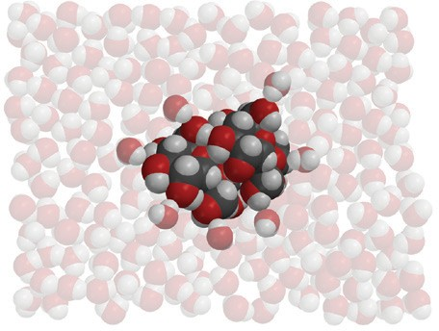
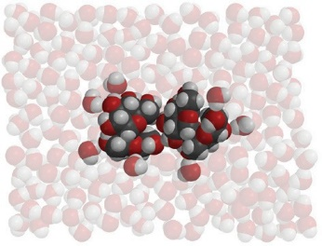
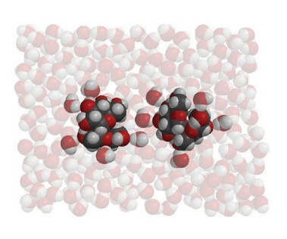
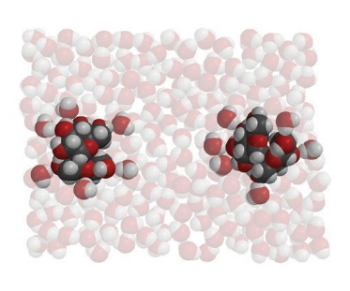

When sucrose is placed in water, the positive area of a water molecule is attracted to the negative area of a sucrose molecule. And the negative area of a water molecule is attracted to the positive area of the sucrose molecule.

When the attraction between water molecules and sucrose molecules overcomes the attraction the sucrose molecules have to other sucrose molecules, they will separate from one another and dissolve. Notice how one whole sucrose molecule breaks away from another whole sucrose molecule. The molecule itself does not come apart into individual atoms.

Another solvent like mineral oil which has only carbon-hydrogen (C–H) bonds is not polar and does not dissolve salt or sugar as well as water does.

Solubility is a characteristic property of a substance
Each substance dissolves in water to a different extent. Another way of saying this is that each substance has its own characteristic solubility. Solubility is usually measured by the number of grams of a substance that dissolves in 100 mL of water at a particular temperature.

It should make sense that different substances would have different solubilities. Since substances are made up of different atoms and ions bonded together differently, they interact with water differently giving them each their own characteristic solubility.

Common substances like sodium chloride (table salt), magnesium sulfate (Epsom salt), monosodium glutamate (MSG), and sucrose (sugar) all are made up of different ions or atoms bonded together differently. Since water interacts with each of these substances differently, they each have their own characteristic solubility.
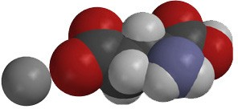
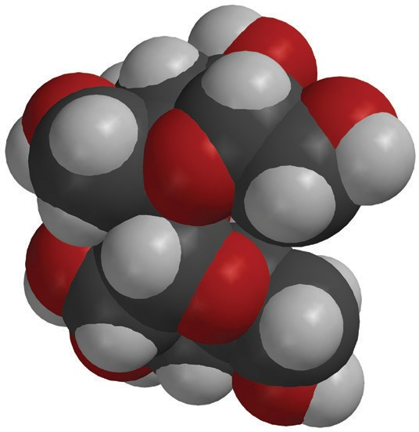
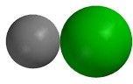
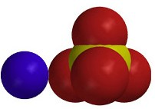
Sodium chloride
Monosodium glutamate

Magnesium sulfate
Sucrose

Temperature affects dissolving
Temperature affects dissolving but it doesn’t have the same effect on all substances. Look at the table and graph below. They show that as the temperature increases, more sodium chloride and more sucrose dissolve in water. They also show that the dissolving of sugar increases with temperature much more than the dissolving of salt.

Comparing the solubility of sodium chloride and sucrose
Measured in grams of solute dissolved in 100 mL of water
Temperature °C | 0 | 20 | 40 | 60 | 80 | 100
Sodium chloride | 35.5 | 36 | 36.5 | 37.5 | 38 | 39
Sucrose | 179 | 204 | 241 | 288 | 363 | 487

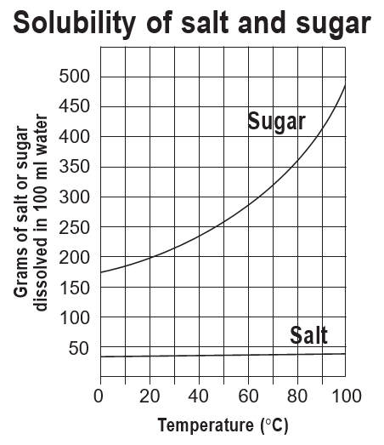

Liquids can dissolve in liquids
Solids aren’t the only substances that can dissolve. Liquids can also dissolve in other liquids. For example, alcohol and corn syrup dissolve in water but mineral oil does not. The polarity of molecules can help explain this.
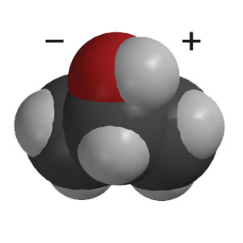
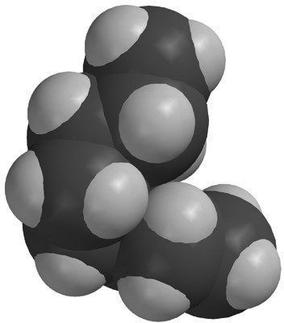
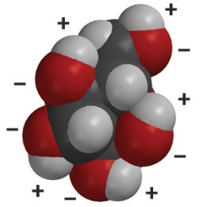
Even though alcohol has one polar area (O–H bond) and a larger nonpolar area (C–H bonds), polar water molecules and the polar area on alcohol molecules are attracted to each other, causing alcohol to dissolve in water.

Glucose has many areas where oxygen is bonded to hydrogen. These O–H bonds are polar. Polar water molecules and the polar areas of glucose molecules are attracted to each other, causing the corn syrup to dissolve.

The mineral oil molecule is made of carbon atoms bonded to hydrogen atoms. The bond between these atoms creates very little polarity. Water is not very attracted to the oil and so does not dissolve it.

Gases can dissolve in liquids
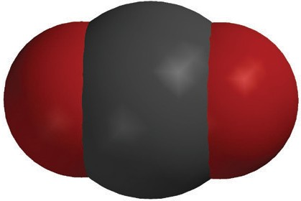
Gases can also dissolve in liquids. A good example is the gas in soda pop. This gas is carbon dioxide (CO₂). In soda pop, molecules of carbon dioxide are thoroughly mixed and dissolved in water. When dissolved, the molecules of CO₂ are not like tiny little bubbles of gas mixed in the water. Instead, single molecules of CO₂ are surrounded by water molecules.
+
_
_
+

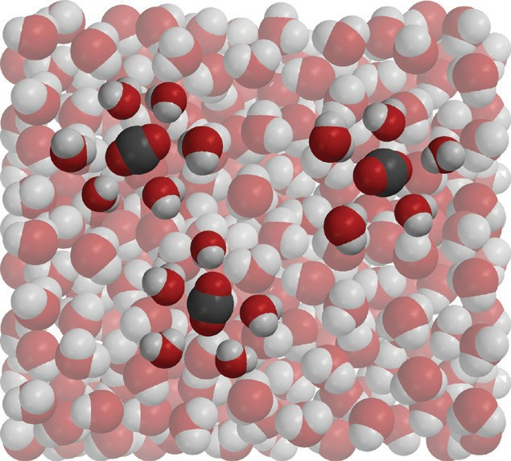
A molecule of carbon dioxide has a slight negative charge near the oxygen and a slight positive charge near the carbon. CO₂ is soluble because water molecules are attracted to these polar areas. The bond between carbon and oxygen is not as polar as the bond between hydrogen and oxygen, but it is polar enough that carbon dioxide can dissolve in water.

Although the CO₂ dissolves, the molecules are not attracted as strongly by the water molecules as substances like salt or sugar. Due to these weaker attractions, the molecules of CO₂ come out of solution relatively easily. This is why soda becomes flat if it is left uncapped for too long.

Heating and cooling affect how much gas stays in a liquid
As you have read, carbon dioxide molecules and water molecules are somewhat attracted to each other, but the attraction is not very strong. Carbon dioxide readily leaves an open container of soda pop. Increasing the temperature of the soda increases this effect. Warming the soda increases the motion of the water and carbon dioxide molecules making their attachments even looser and allowing the gas to escape even faster.

Look at the graph to see how the concentration of carbon dioxide in water changes with temperature.
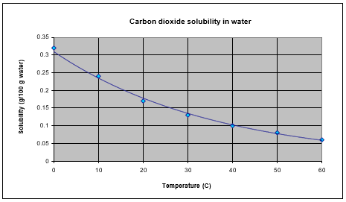
You can see that at the lowest temperature, the concentration of CO₂ is the highest. At the highest temperature, the concentration of CO₂ is the lowest.
If you compare the solubility graph for carbon dioxide with the solubility graph for sucrose, you can see that the line moves in the opposite direction. The curve showing the solubility of carbon dioxide goes down as the temperature of the water increases, while the curve showing the solubility of sucrose goes up as the temperature of the water increases. More sucrose can dissolve in hot water than in cold. But for carbon dioxide, more can dissolve in cold water than in hot.

Dissolving can cause a change in temperature

You have seen that the temperature of the solvent affects how much solute dissolves. But it is also true that the actual process of dissolving can cause a change in temperature. There is a principle in chemistry that states:

It takes energy to break bonds, and energy is released when bonds are formed.

Normally these concepts are used when talking about chemical reactions which will be discussed in Chapter 6. But the same principles apply in a related way to the process of dissolving. When water molecules are attracted to and attach to the solute, energy is released. And when the movement of the molecules causes the solute to come apart, energy is absorbed. The absorbing and releasing of energy in dissolving can help explain why the temperature goes up when some solutes are dissolved and goes down when others are dissolved.

Exothermic Dissolving
If dissolving is exothermic, that means that it takes less energy for water molecules to break apart the solute than is released when the water molecules attract and attach to the solute. Overall, the temperature increases.
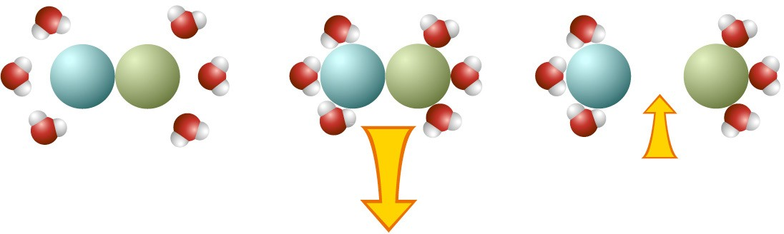

Endothermic Dissolving
If dissolving is endothermic, it takes more energy for water molecules to break apart the solute than is released when the water molecules attract and attach to the solute. Overall, the temperature decreases.
