Activity Sheet Answers
Chapter 5, Lesson 1
Temperature and Density

EXPLAIN IT WITH ATOMS & MOLECULES

- Do the shared electrons in the water molecule spend more time near the oxygen atom or the hydrogen atoms? Why?
The shared electrons in a water molecule spend more time near the oxygen atom than the hydrogen atoms. This is because the electrons are more attracted to the oxygen atom.

- What do the colors and positive and negative signs on the electron cloud (charge density) model represent?
The colors on a charge density model of water show areas where electrons are more or less likely to be found at any given instant. The positive and negative signs also show where electrons are more concentrated. Because electrons have a negative charge, areas where they are more concentrated (near the Oxygen atom in the case of water) are sometimes indicated with a negative sign. Areas where electrons are less concentrated are sometimes indicated by a positive sign.

- Why are water molecules so attracted to each other?
Water molecules are attracted to one another because they have slight areas of positive and negative charge. The slight positive area on one water molecule is attracted to the slight negative area of another water molecule. These attractions keep water molecules near each other.

- Attractions are important in three different ways. Draw a line between the picture and the description of the attractions.

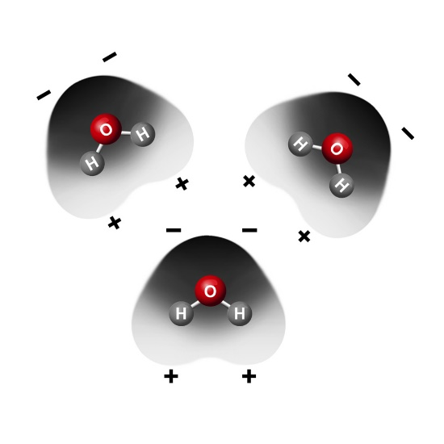
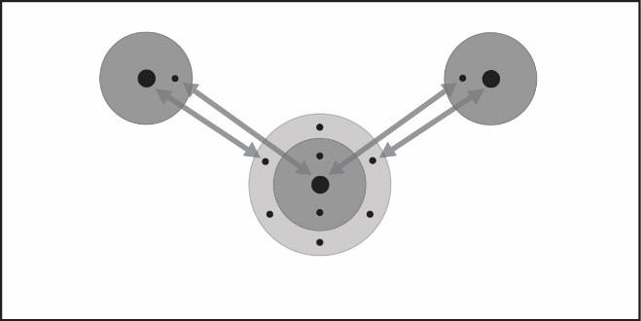
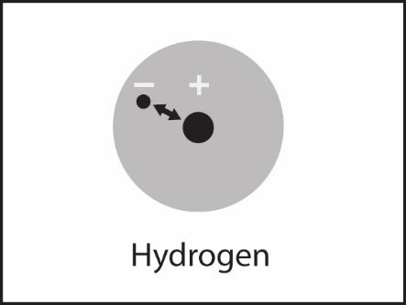
The electrons of each atom are attracted to the protons in the other atom. These mutual attractions keep two or more atoms together as a covalently bonded molecule.
The positive areas of one molecule are attracted to the negative areas of another molecule. These mutual attractions keep the substance together.
The electrons are attracted to the protons in an atom. These attractions keep an atom together.

ACTIVITY

- What do the red “–” signs on the oxygen atom represent?
The red negative signs on the atom represent the areas of slight negative charge on the water molecule.

- What do the blue “+” signs on the hydrogen atoms represent?
The blue positive signs on the hydrogen atoms represent the areas of slight positive charge within a water molecule.

- Because water molecules are polar, how do they arrange themselves in liquid water?
Because water molecules are polar, the area of positive charge in one molecule is attracted to the areas of negative charge in another water molecule. These areas attract each other, and the molecules tend to arrange themselves based on these attractions.

- How would you design an experiment to find out which evaporates faster, alcohol or water? Be sure to explain how you would control variables.
Answers will vary by student.

ACTIVITY

- Which evaporated faster, water or alcohol?
Alcohol evaporated faster than water.

- The following molecular models show the polar regions of alcohol and water. Why does alcohol evaporate faster?
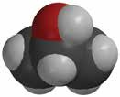
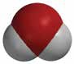
–
+
–
–
+
+

Alcohol evaporates faster than water because it only has one area which is polar so the molecules do not attract each other as much as water molecules attract one another. The isopropyl alcohol is also a bigger molecule, so it is more difficult for it to get as close to another alcohol molecule as it is for a water molecule to be associated with another water molecule.

TAKE IT FURTHER
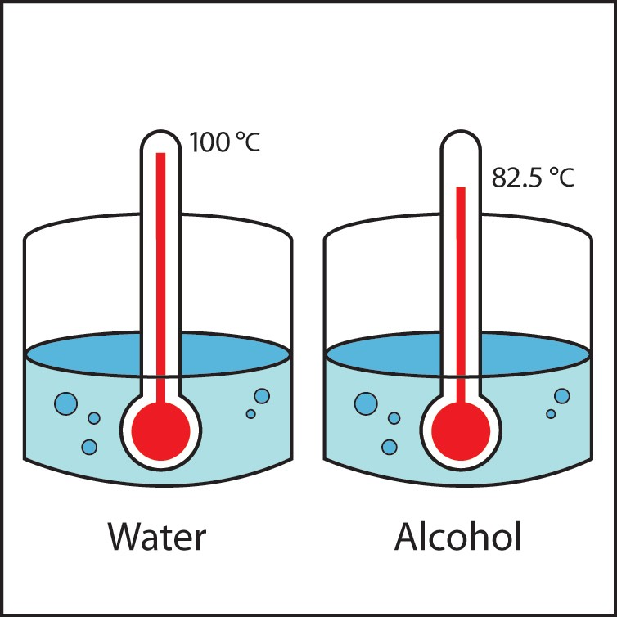
- This illustration shows that alcohol boils at a lower temperature than water. Knowing what you do about the polarity of water and alcohol, explain why alcohol boils at a lower temperature than water.
Alcohol molecules are less attracted to one another than water molecules are to each other. This is why alcohol evaporates faster than water and also why alcohol boils at a lower temperature than water. The attractions between alcohol molecules are more easily overcome when the liquids are heated so alcohol boils at a lower temperature than water.

