Activity Sheet Name Chapter 5, Lesson 1
Water is a Polar Molecule Date

EXPLAIN IT WITH ATOMS & MOLECULES
This model of a water molecule shows the number of electrons that can be found in each energy level. It also shows that oxygen and hydrogen share electrons in a covalent bond. But it doesn’t show where electrons are most likely to be at any given moment.

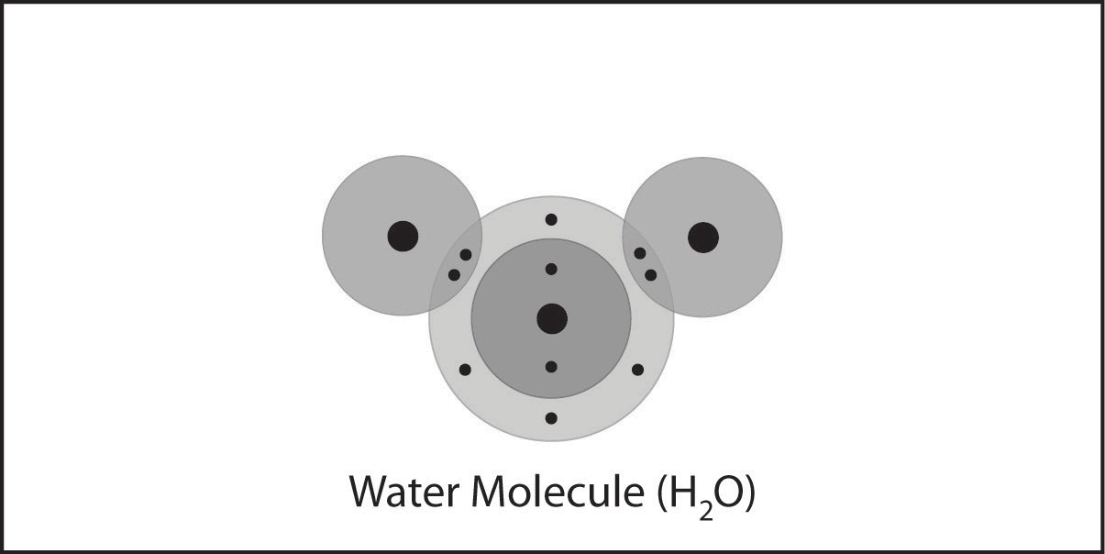

- Do the shared electrons in the water molecule spend more time near the oxygen atom or the hydrogen atoms?

Why?

- What do the colors and positive and negative signs on the electron cloud model represent?

- Why are water molecules so attracted to each other?

- Attractions are important in three different ways. Draw a line between the picture and the description of the attractions.
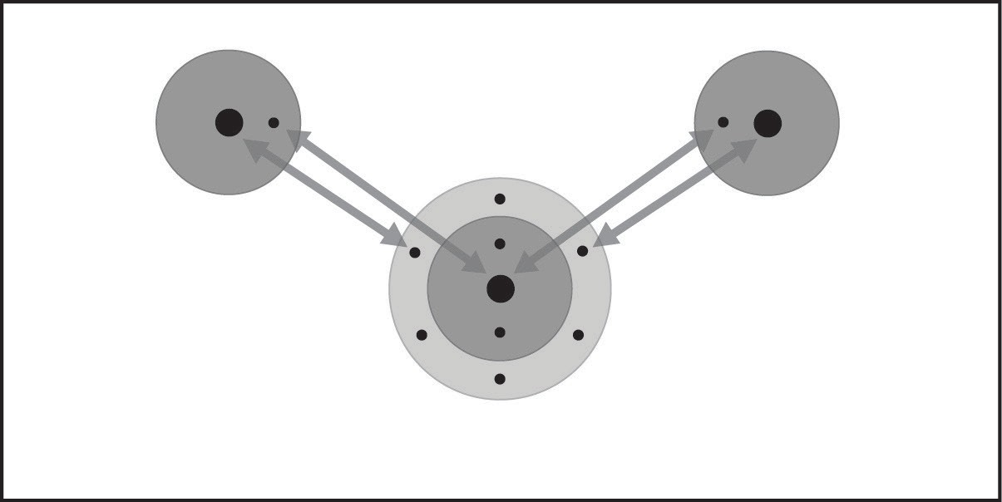
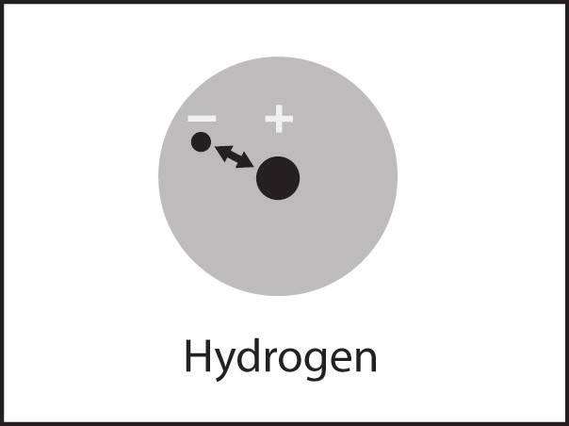
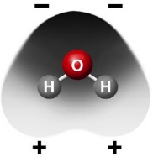
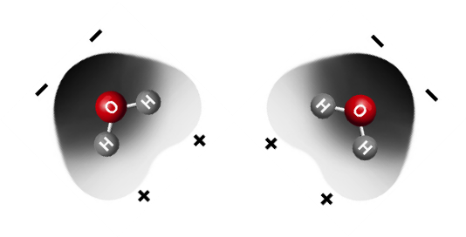
Within an atom

Between the atoms in a molecule

Between molecules

The electrons of each atom are attracted to the protons in the other atom.
These mutual attractions keep two or more atoms together as a covalently bonded molecule.

The positive areas of one molecule are attracted to the negative areas of another molecule. These mutual attractions keep a substance together.

The electrons are attracted to the protons in an atom. These attractions keep an atom together.

ACTIVITY
Mark the positive and negative areas on a water molecule.

Materials for Each Group
- Styrofoam water molecule models from Chapter 2, Lesson 2 (two per student)
- Permanent markers (blue and red)

Procedure
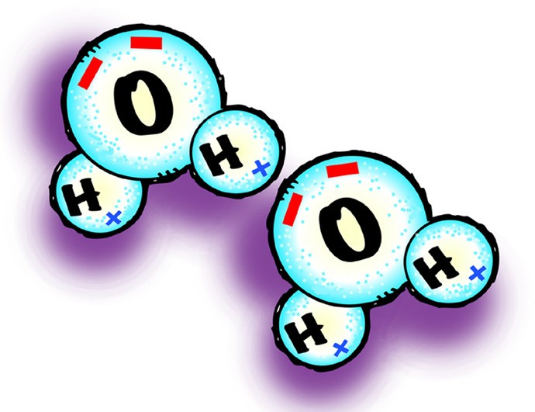
  - Draw a blue “+” on each of the hydrogen atoms.
  - Draw two red “–” at the bottom of the oxygen atom.
  - Repeat this for your other water molecule.
  - Position your water molecules so that opposite charges are near each other.

- What do the red “–” signs on the oxygen atom represent?

- What do the blue “+” signs on the hydrogen atoms represent?

- Because water molecules are polar, how do they arrange themselves in liquid water?

- How would you design an experiment to find out which evaporates faster, alcohol or water? Be sure to explain how you would control variables.

ACTIVITY

Question to Investigate
Does water evaporate faster or slower than less-polar alcohol?

Materials for Each Group
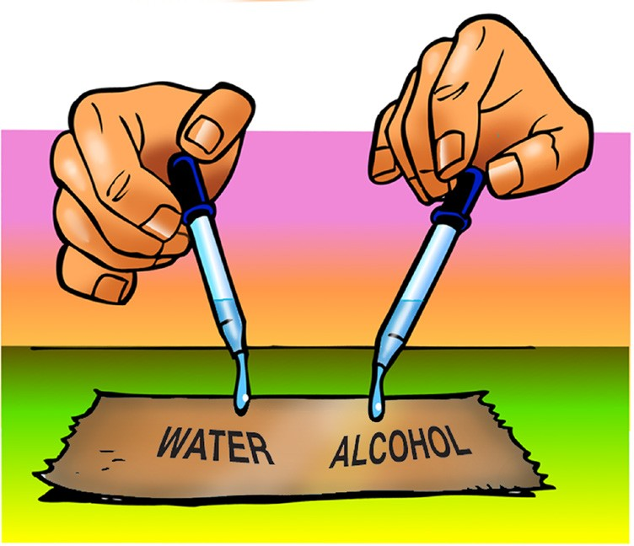
  - Isopropyl alcohol (70% or higher)
  - Water
  - Brown paper towel
  - Droppers

Procedure
- At the same time, place 1 drop of water and 1 drop of alcohol on a brown paper towel. Observe.

- Which evaporated faster, water or alcohol?

- The following molecular models show the polar regions of alcohol and water. Why does alcohol evaporate faster?

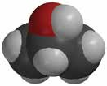
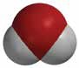
–
+
–
–
+
+

TAKE IT FURTHER
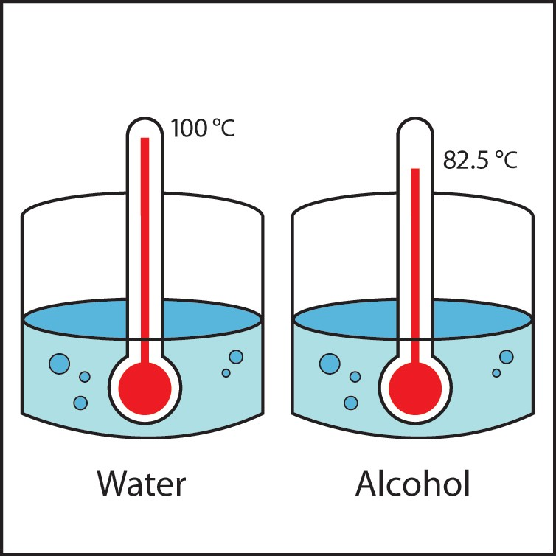
- This illustration shows that alcohol boils at a lower temperature than water. Knowing what you do about the polarity of water and alcohol, explain why alcohol boils at a lower temperature than water.

