Activity Sheet Name Chapter 5, Lesson 3
Why Does Water Dissolve Salt? Date

INTRODUCTION
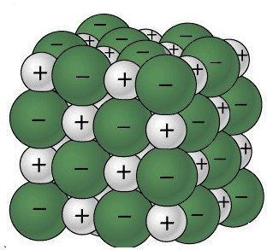
- What is it about water molecules and the ions in salt that might make water able to dissolve salt?

Question to Investigate
How does salt dissolve in water?

Materials
  - Activity sheet with sodium and chloride ions and water molecules
  - Construction paper, any color
  - Scissors
  - Tape or glue

Procedure
Make a model of a salt crystal
- Cut out the ions and water molecules.
- Arrange the ions on a piece of construction paper to represent a 2-dimensional salt crystal. Do not tape these pieces down yet.

Model how water dissolves salt
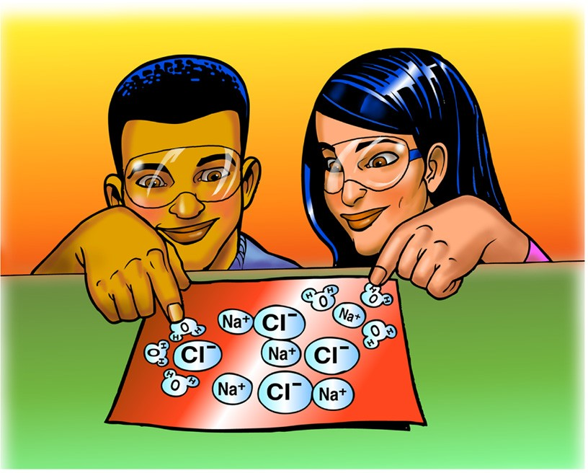
- Look at an image and animation showing how water molecules dissolve salt. Then arrange the water molecules around the sodium and chloride ions in the correct orientation. The positive part of the water molecules should be near the negative chloride ion. The negative part of the water molecules should be near the positive sodium ion.
- Move the water molecules and sodium and chloride ions to model how water dissolves salt.
- Tape the molecules and ions to the paper to represent water dissolving salt.

- Describe what happens when water dissolves salt.
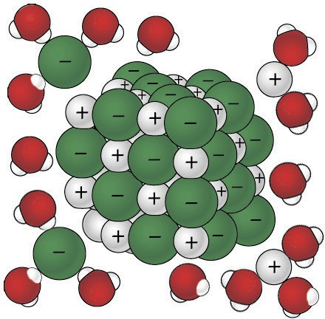
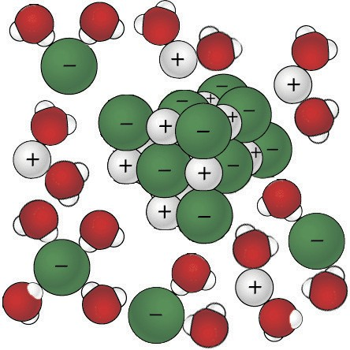
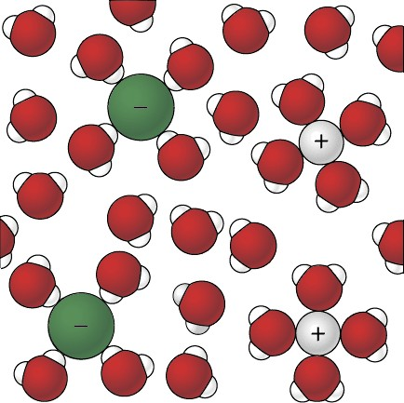

ACTIVITY

Question to Investigate
Is alcohol just as good, better, or worse than water at dissolving salt?

Materials for Each Group
  - Water
  - Isopropyl alcohol (70% or higher)
  - Salt
  - Balance
  - 2 clear plastic cups
  - 2 small plastic cups
  - Graduated cylinder

Procedure
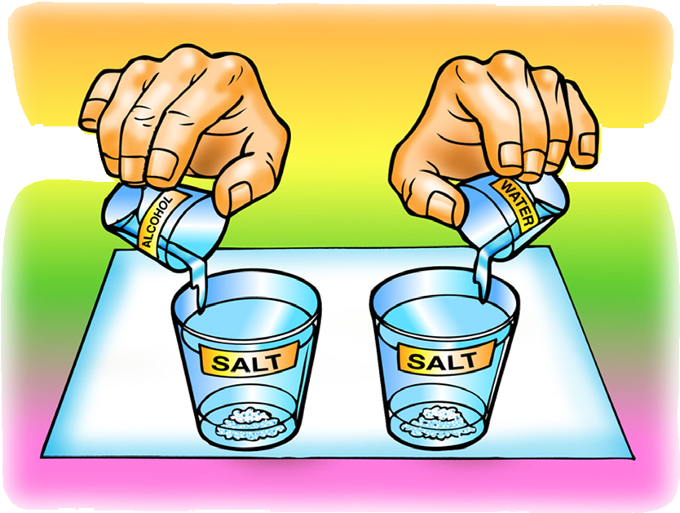
- In separate cups, measure two samples of salt that weigh 5 grams each.
- Place 15 mL of water and alcohol into separate cups.
- At the same time, add the water and alcohol to the samples of salt.
- Swirl both cups the same way for about 20 seconds and check for the amount of salt dissolved.
- Swirl for another 20 seconds and check. Swirl for the last 20 seconds and check.
- Carefully pour off the water and alcohol from the cups and compare the amount of undissolved salt left in each cup.

- Select two variables and explain how they are controlled in this procedure.

- Is alcohol just as good, better, or worse than water at dissolving salt?

How do you know?

EXPLAIN IT WITH ATOMS & MOLECULES
- Think about the polarity of water and alcohol to explain why water dissolves salt better than alcohol does.
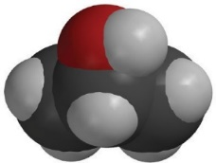
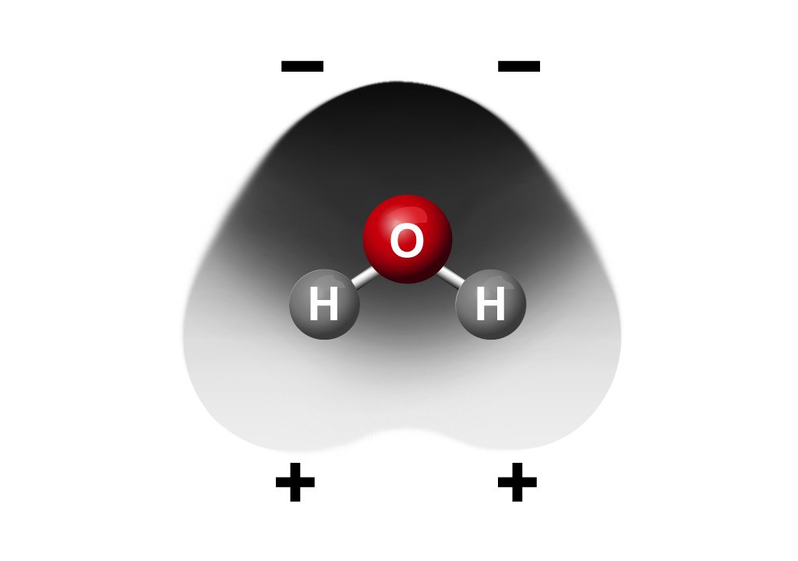
–
+

TAKE IT FURTHER

Question to Investigate
Do all ionic substances dissolve in water?

Materials for Each Group
  - Sodium bicarbonate
  - Calcium carbonate
  - Water
  - 2 clear plastic cups
  - 2 small plastic cups
  - Balance

Procedure
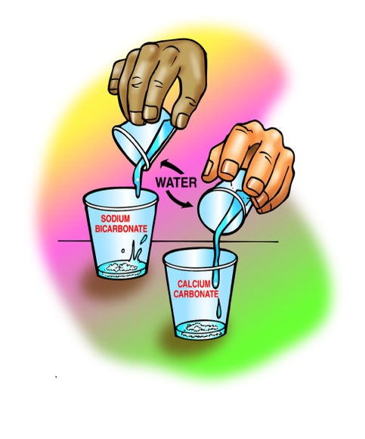
- Label two clear plastic cups sodium bicarbonate and calcium carbonate.
- Measure 2 g each of sodium bicarbonate and calcium carbonate and put them in their labeled cups.
- Measure 30 mL of water into each of two empty cups.
- At the same time, pour the water into the sodium bicarbonate and calcium carbonate cups.
- Gently swirl both cups for about 1 minute.

- Do all ionic substances dissolve in water?

How do you know?

