Activity Sheet Answers
Chapter 5, Lesson 4
Why Does Water Dissolve Sugar?

INTRODUCTION

- What happens to the sugar and color coating when an M&M is placed in water?
When an M&M is placed in water, the sugar and color coating dissolves, leaving behind just the chocolate.

- Knowing what you do about the polarity of water, why do you think water dissolves sugar?
Water dissolves sugar because both are polar molecules which means that both have areas of positive and negative charge. The areas of slight positive and negative charge in water are attracted the negative and positive areas in sugar molecules. When the attractions between water and individual sugar molecules overcome the attraction that sugar molecules have for other sugar molecules, sugar dissolves.

EXPLAIN IT WITH ATOMS & MOLECULES

- Sucrose makes up the sugar we commonly use. The chemical formula for sucrose is C₁₂H₂₂O₁₁. What do these letters and numbers mean?
The chemical formula C₁₂H₂₂O₁₁ means that one sucrose molecule contains 12 carbon atoms, 22 hydrogen atoms, and 11 oxygen atoms.

- What do the + and – signs around certain parts of the sucrose molecule mean?
The positive and negative signs around a sucrose molecule show the polar part of the molecule where an oxygen and hydrogen atom are bonded.

- Look at the pictures below and describe what happens when water dissolves sucrose. Be sure to discuss the polarity of both water and sucrose.
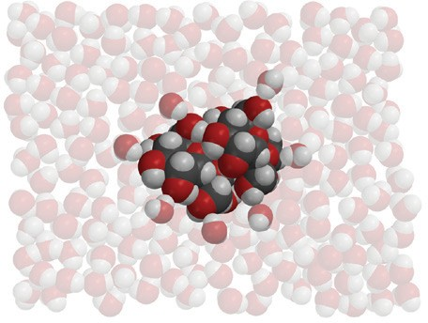
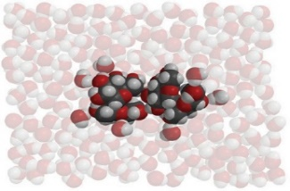
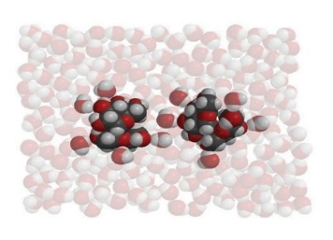
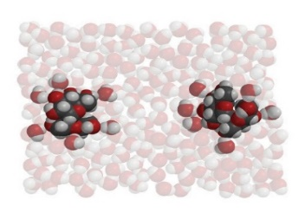

Areas of positive and negative charge on a water molecule are attracted to opposite areas of negative and positive charge in a sucrose molecule. As water molecules associate with the sucrose, the attractions between water and individual sucrose molecules begin to overcome the attractions that the sucrose molecules have for one another. The water pulls away the sucrose molecules one by one, dissolving the sugar.
ACTIVITY

- Draw a line from the solvent to the description to show how well each solvent dissolves the sugar and color coating of an M&M.
Water
Isopropyl alcohol
Mineral oil
Doesn’t dissolve the sugar and color at all
Dissolves the sugar and color very well
Dissolves a small amount of the sugar and color

EXPLAIN IT WITH ATOMS & MOLECULES
The polarity of a solvent and how well sucrose dissolves in it
Solvent | How polar is the solvent? | How?
Water | Polar | Dissolves totally
Isopropyl alcohol | Slightly polar | Dissolves some
Oil | Non-polar | Doesn’t dissolve at all

TAKE IT FURTHER
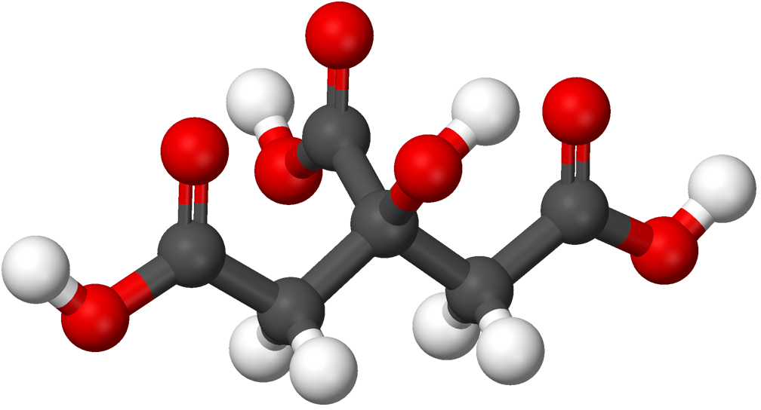
Citric acid molecule
- Citric acid occurs naturally in fruits like oranges, lemons, and limes. It is dissolved in the water within the fruit and contributes to the fruit’s sour taste. When it isn’t dissolved in water, citric acid molecules are attracted to other citric acid molecules within a crystal.

The chemical formula for citric acid is C₆H₈O₇ and it is very soluble in water. Why do you think citric acid is so soluble in water?

Citric acid is very soluble in water because, like water, it has oxygen-hydrogen bonds giving it areas of slight positive and negative charge. Water is attracted to these areas. Water’s attraction for each citric acid molecule is able to overcome the attractions that citric acid molecules have for other citric acid molecules, and so the substance dissolves in water.

