Chapter 5, Lesson 6—Does Temperature Affect Dissolving?
Key Concepts
- Adding energy (heating) increases molecular motion.
- Increased molecular motion competes with the attraction between solute molecules and tends to make them come apart more easily.
- Increased molecular motion causes more solvent molecules to contact solute molecules and pull on them with more force, usually resulting in more dissolving.
- Since different substances are made from different atoms, ions, or molecules, increased temperature will affect their dissolving to different extents.

Summary
Students revisit the dissolving M&M activity from Lesson 4. They will design an experiment to see if temperature affects the amount of dissolving of the sugar coating of an M&M.

Objective
Students will be able to identify and control variables to design an experiment to see whether the temperature of a solvent affects the speed at which a solute dissolves. Students will be able to explain, on the molecular level, why increasing temperature increases the rate of dissolving.

Evaluation
The activity sheet will serve as the “Evaluate” component of each 5-E lesson plan. The activity sheets are formative assessments of student progress and understanding. A more formal summative assessment is included at the end of each chapter.

Safety
Use caution when handling hot water.

Materials for Each Group
- M&M’s (3 same color)
- 3 clear plastic cups
- 1 sheet of white paper
- Room temperature water
- Hot water (about 50 °C)
- Cold water (about 5 °C)
Materials for the Demonstration
- 4 graduated cylinders (50 mL)
- Hot water (about 50 °C)
- Cold water (about 5 °C)
- Salt
- Sugar
- Tablespoon
- 2 small cups

ENGAGE

Have students work in groups to design an experiment to investigate whether the temperature of water affects the amount of M&M coating that dissolves.
Remind students of the experiment they did in Lesson 4 in which they placed an M&M in water and watched the colored sugar coating dissolve. In that experiment, students used water and then alcohol and oil to see if the solvent used affects the dissolving of the M&M coating.

Ask students:

What could you investigate about M&M’s dissolving in water?
If students do not suggest changing the temperature of the water, ask whether they think the temperature of the water affects the amount of coating that dissolves.

Give each student an activity sheet.
Students will describe their experimental design, record their observations, and answer questions about the activity on the activity sheet. The Explain It with Atoms & Molecules and Take It Further sections of the activity sheet will either be completed as a class, in groups, or individually, depending on your instructions. Look at the teacher version of the activity sheet to find the questions and answers.

Have student groups discuss the following questions:

How could you investigate whether the temperature of water affects the amount of coating that dissolves from an M&M?
  - What are the variables in this experiment, and how will you control them?

As you visit the groups and listen to their discussions, check to see if students are thinking about variables such as:
- Kind of container
- Amount of water
- Color of the M&M’s
- When the M&M’s are placed in the water
- Location of the M&M’s in each cup

All these variables should be kept the same. Students should realize that the only variable that should be changed is the temperature of the water.

Have student groups share their ideas for comparing the effect of temperature on dissolving and consider how each plan controls variables.
As each group presents their plans, have the class identify how each plan controls variables. Some groups may have planned to test M&M’s in hot and cold water but didn’t consider using room temperature water, too. Encourage all groups to test an M&M in all three temperatures of water. The room temperature water serves as a control and can help students see the difference in how temperature affects dissolving.

EXPLORE

Have groups place an M&M in cold, room temperature, and hot water at the same time to investigate the effect of temperature on dissolving.
Question to Investigate
Does the temperature of water affect the amount of coating that dissolves from an M&M?

Materials for Each Group
- 3 same-colored M&M’s
- 3 clear plastic cups
- 1 sheet of white paper
- Room temperature water
- Hot water (about 50 °C)
- Cold water (about 5 °C)

Procedure
- Pour cold, room temperature, and hot water into the cups so that the water is deep enough to cover an M&M.

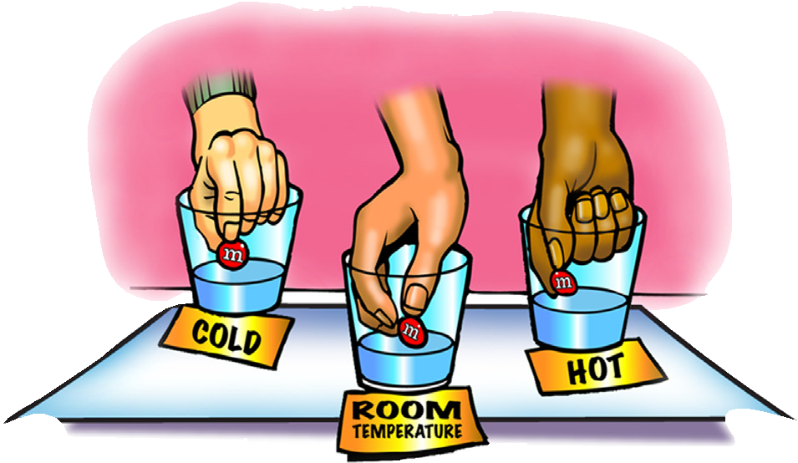
- Place the three cups on the white paper. Write Cold, Room temp, and Hot near its cup.

- With the help of your partners, place a same-colored M&M in the center of each cup at the same time. Observe for about 1 minute.

Expected Results
More color and sugar dissolve from the M&M in the hot water and less in the room temperature and cold water. This means there is more chocolate visible on the M&M in the hot water than there is in the room temperature and cold water. The color and sugar in the room temperature water dissolve somewhere between the cold and hot water but are more similar to the cold than the hot.
Note: There are actually two processes happening in this activity. The color and sugar are dissolving in the water, but they are also diffusing in the water. The temperature of the water affects the amount of dissolving, but it also affects the rate of diffusion. Students should focus on the surface of the M&M to judge the amount of color and sugar that dissolves.

Record and discuss student observations.
Ask students:

Does the temperature of the water affect the amount of colored coating that dissolves from an M&M? How do you know?
Based on their observations, students should conclude that the hotter water causes more dissolving. Students may have noticed a greater difference in the amount of dissolving between the hot and the room temperature water than between the room temperature and the cold water. If no one comments on this, suggest that there is a difference.

EXPLAIN

Discuss how differences in molecular motion caused more of the sugar coating to dissolve in hot than in cold water.
Ask students:

What are the differences in the way water molecules move in cold, room temperature, and hot water?
Students should remember that water molecules move faster in hot water than in cold.

Why do you think sugar dissolves better in hot water than in cold water?
The reason why sugar dissolves at a faster rate in hot water has to do with increased molecular motion. The added energy in the hot water causes water molecules to move faster and sucrose molecules to vibrate faster. This added movement tends to make the bonds between sucrose molecules easier to overcome. When faster-moving water molecules attach to sucrose molecules, a higher proportion of these sucrose–water interactions have enough energy to pull sucrose molecules away from other sucrose molecules, so the rate of dissolving increases.

Why do you think there is a greater difference in the amount of dissolving between the hot and room temperature water than between the room temperature and cold water?
There is a greater difference in the rate of dissolving because there is a greater difference in temperature between hot and room temperature water (about 30 degrees) than between room temperature and cold water (about 15 degrees).

EXPLORE

Either do a demonstration or show a video to investigate whether all substances dissolve much better in hot water than in cold water.
Ask students to make a prediction:

In the activity, you have seen that hot water dissolves sugar better than cold water. Do you think that salt will dissolve much better in hot water than in cold, like sugar does?

Project the image Hot and Cold Water Dissolve Salt vs. Sugar.
www.acs.org/middleschoolchemistry/simulations/chapter5/lesson6.html

If you choose to do the demonstration, follow the procedure below.

Question to Investigate
Will salt dissolve much better in hot water than in cold, like sugar does?

Materials for the Demonstration
- 4 graduated cylinders (50 or 100 mL)
- Hot water (about 50 °C)
- Cold water (about 5 °C)
- Salt
- Sugar
- Tablespoon
- 4 small cups

Teacher Preparation
- Label two small cups salt and two cups sugar.
- Place 1 tablespoon of salt and 1 tablespoon of sugar in each of their labeled cups.

Procedure
Salt in Hot and Cold Water
- Place 25 mL of hot water and 25 mL of cold water in two separate graduated cylinders.
- At the same time, pour one tablespoon of salt into each graduated cylinder. Do not swirl, shake, or stir. Set these graduated cylinders aside.

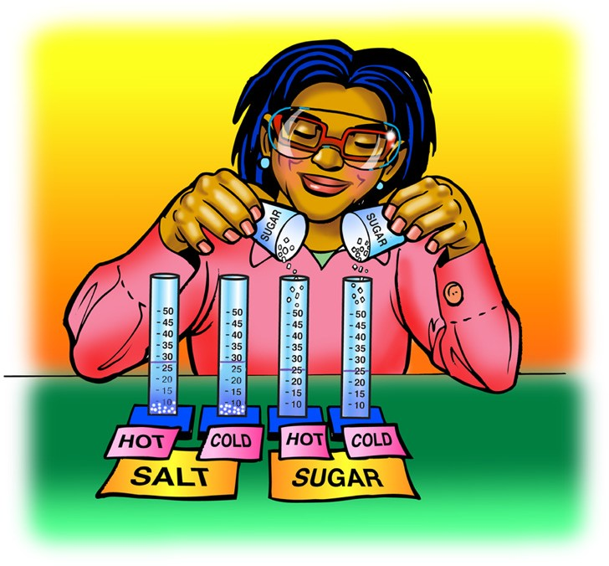
Sugar in Hot and Cold Water
- Place 25 mL of hot water and 25 mL of cold water in two separate graduated cylinders.
- At the same time, pour one tablespoon of sugar into each graduated cylinder. Do not swirl, shake, or stir. Set these graduated cylinders aside.

Compare the amounts of salt and sugar left undissolved
- Show students the graduated cylinders with the salt.
- Show students the graduated cylinders with the sugar.

Expected Results
Less sugar is visible in the hot water than in the cold, meaning that more sugar dissolves in the hot water than in the cold water. There is no obvious difference between the amount of salt that dissolves in the hot water compared to the cold water. This shows that temperature affects the dissolving of sugar more than it affects the dissolving of salt.

Show students the table and graph for the solubility of sugar and salt at different temperatures.

Project the graph Solubility of Salt and Sugar.
www.acs.org/middleschoolchemistry/simulations/chapter5/lesson6.html
Help students understand that the graph shows that more sugar dissolves in water as the temperature of the water increases. Also help them to see that the dissolving of salt also increases as the temperature of the water increases. But the dissolving of salt does not increase nearly as much as sugar.

Comparing the solubility of sodium chloride and sucrose
Measured in grams of solute dissolved in 100 mL of water
Temperature °C | 0 | 20 | 40 | 60 | 80 | 100
Sodium chloride | 35.5 | 36 | 36.5 | 37.5 | 38 | 39
Sucrose | 179 | 204 | 241 | 288 | 363 | 487
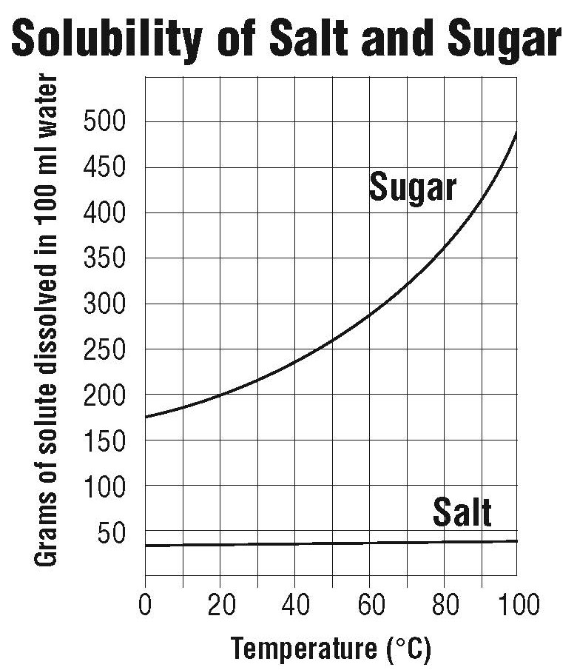

Note: Students may ask why so much more sugar dissolves at higher temperatures compared to salt. This is not easy to explain on the molecular level at a middle school, high school, or even college level. Tell students that since substances are composed of different atoms, ions, and molecules, they are held together differently and interact with water differently. Changing temperature also affects the motion of the atoms, ions, or molecules of the substance and affects the interaction between water molecules and the particles of the substance. There are so many factors involved that it is difficult to explain why the solubility of one substance is affected more than another by an increase in temperature.

Ask students:
- The demonstration showed that temperature affects the dissolving of sugar more than it affects the dissolving of salt. Explain how the graph shows this.
As the temperature increases, more and more sugar can be dissolved, but only slightly more salt can be dissolved.
- How much sugar dissolves in 100 mL of water at 50 °C?
About 260 g of sugar will dissolve.

How much salt dissolves in 100 mL of water at 50 °C?
About 37 g of salt will dissolve.

EXTEND

Plot a solubility curve for potassium chloride and compare it to the solubility of sugar and salt.
Tell students that they will plot the solubility of potassium chloride on a graph provided on the activity sheet. Explain that potassium chloride is used as a salt substitute for people who should not eat regular salt (sodium chloride.)
The solubility of potassium chloride
Measured in grams of solute dissolved in 100 mL of water
Temperature °C | 0 | 20 | 40 | 60 | 80 | 100
Potassium chloride | 28 | 33 | 38 | 44 | 50 | 55
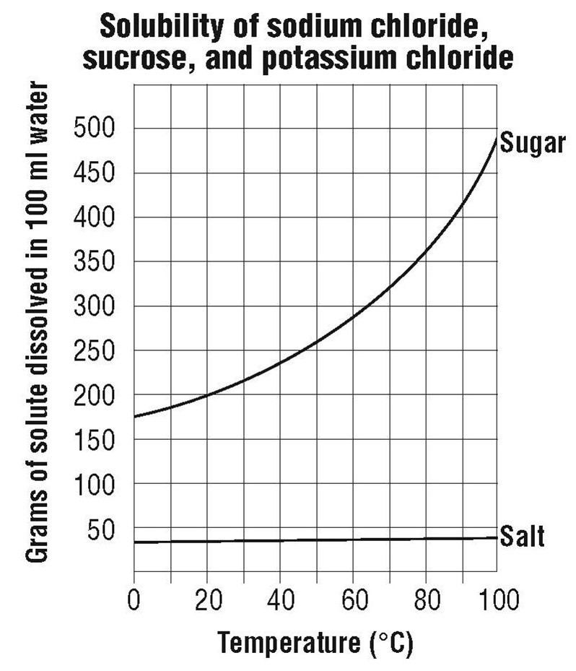

Ask students:
- At what temperature would you say that the solubility of sodium chloride and potassium chloride are about the same?
- At 0 °C, which substance is the least soluble?
- At 0 °C, which substance is the most soluble?

