Activity Sheet Answers
Chapter 5, Lesson 8
Can Gases Dissolve in Water?

DEMONSTRATION

- What gas is inside the bubbles you saw when your teacher opened a bottle of carbonated water?
Carbon dioxide

- Where was this gas before the bottle was opened?
Before the bottle was opened, carbon dioxide molecules were dissolved in the water.
EXPLAIN IT WITH ATOMS & MOLECULES

- Why does carbon dioxide dissolve in water?
Carbon dioxide dissolves in water because its molecules have areas of slight positive and negative charge. These are formed by an unequal sharing of electrons between the oxygen and carbon atoms in the molecule. These polar areas are attracted to the opposite areas of negative and positive charge on a water molecule resulting in dissolving.

- Why does carbon dioxide gas come out of solution (opposite of dissolving) so easily?
Carbon dioxide comes out of solution easily because the attractions between individual carbon dioxide molecules and water molecules are weak.

ACTIVITY
- What was it about the pipe cleaner and M&M that caused bubbles to form?
The pipe cleaner and M&M candy caused bubbles to form in the carbonated water because they contain rough areas where carbon dioxide molecules can collect. When enough carbon dioxide molecules join together, they form a bubble.

- While drinking soda pop with a straw, you may have noticed that bubbles form on the outside of the straw. Now that you have done this activity, why do you think these bubbles form on the straw?
Bubbles form on a straw in soda because although the straw seems smooth, it has tiny bumpy areas at the molecular level. These tiny bumps allow carbon dioxide molecules to collect, which eventually form bubbles.

ACTIVITY
- Does carbon dioxide stay dissolved better in hot water or in cold water? How do you know?
Carbon dioxide stays dissolved better in cold water. This was shown in the experiment. More bubbles form in the carbonated water that was heated. Because more bubbles were forming, it meant that more carbon dioxide was leaving the solution, and therefore more stays dissolved in colder solutions.

- Based on what you observed in this experiment, why do you think people store soda pop in the refrigerator after the bottle has been opened?
People probably store soda in the fridge to keep more of the dissolved carbon dioxide in solution, which prevents the soda from going flat. They probably also like their soda cold, too.

EXPLAIN IT WITH ATOMS & MOLECULES

- Why does warming carbonated water make it easier for carbon dioxide to come out of solution?
Warming carbonated water makes it easier for carbon dioxide to come out of solution because in a warm solution, the carbon dioxide molecules have more energy, and can more easily overcome the attractions between themselves and the surrounding water molecules.

- Look at the graph showing the solubility of carbon dioxide in water to answer the following questions.
Carbon dioxide solubility in water
0.35

0.3

0.25

0.2

0.15

0.1

0.05

0
0
10
20
30
40
50
60
Temperature (C)

a. As the temperature increases, is carbon dioxide more soluble in water or less soluble in water?
As the temperature increases, carbon dioxide is less soluble in water.

b. Does this graph match or not match your observations? Explain.
This graph matches the observations made in the experiment. In the experiment, we saw that more carbon dioxide remained dissolved in cooler solutions. This graph shows the same thing. Carbon dioxide is most soluble at lower temperatures and is increasingly less soluble as the temperature is raised.

- What do the graphs below tell you about the solubility of carbon dioxide compared to sucrose, as temperature increases?
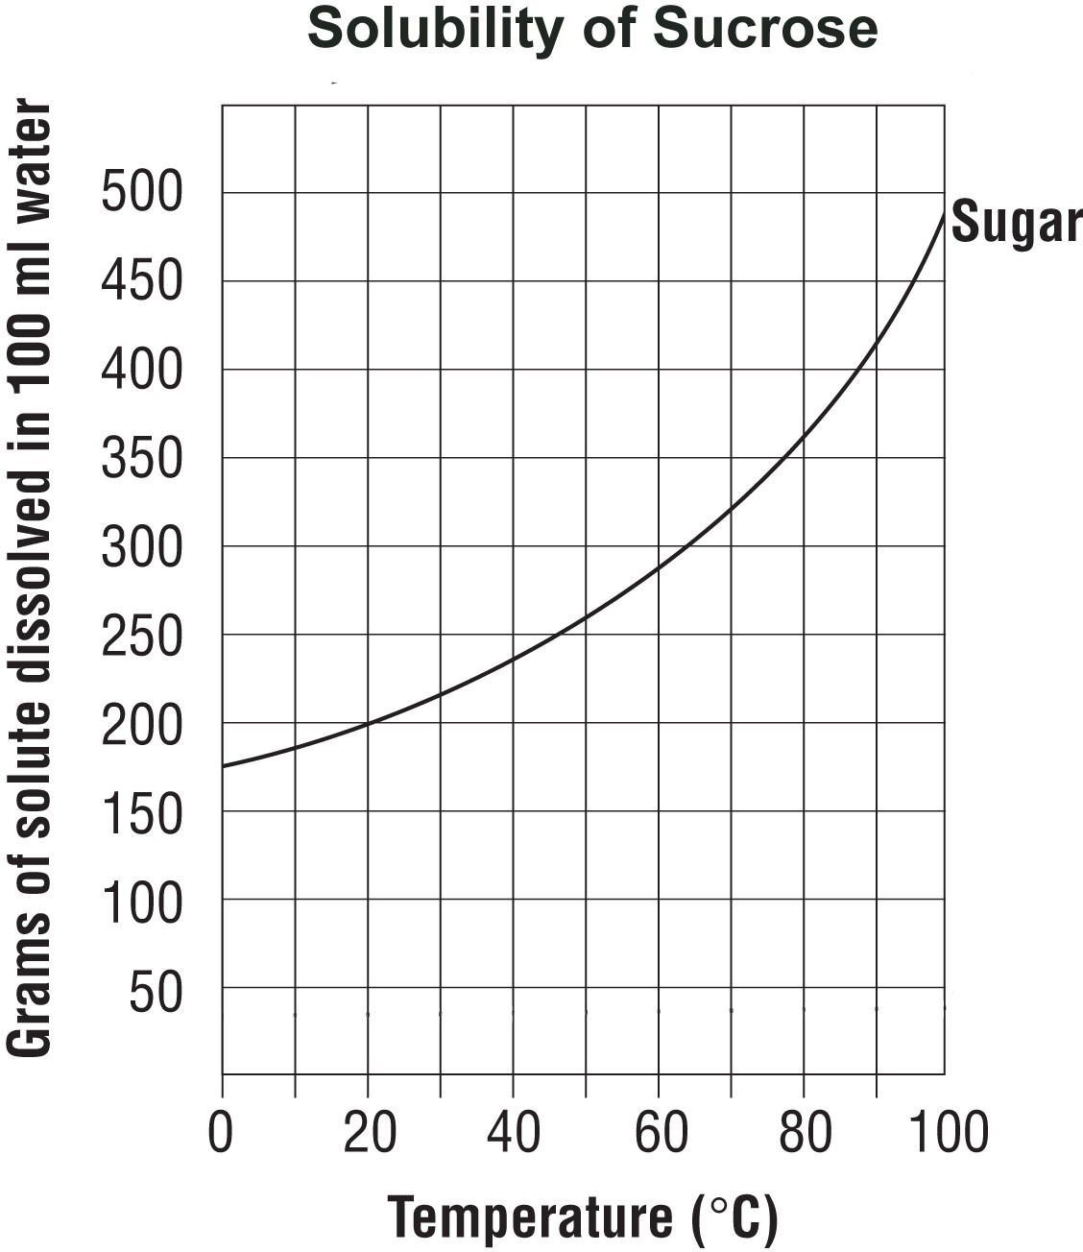
While carbon dioxide is less soluble in water at higher temperatures, sugar is more soluble in water at higher temperatures.
Carbon dioxide solubility in water
0.35

0.3

0.25

0.2

0.15

0.1

0.05

0
0
10
20
30
40
50
60
Temperature (C)

TAKE IT FURTHER

- During a long hot summer, you may notice fish gulping air at the surface of a pond. Why do you think the fish come to the surface like this, instead of breathing dissolved oxygen in the water the way that they normally do?
There is less dissolved oxygen in the warmer water and the fish try to get some from the air.

- Coal-burning power plants heat water to turn turbines to make electricity. After using the water, it is cooled and then returned to the river or lake it came from. Why is it important to cool the water before returning it to the river?
It is important to cool water when returning it to a lake or river after using it for industrial purposes because the temperature of the water can affect how much oxygen is dissolved in it which is important to the plants and animals in the water.

- What causes the fantastic “fountain” when a roll of Mentos mints is dropped in a bottle of Diet Coke?
When Mentos are dropped in a bottle of Diet Coke, tiny ridges on the surface of the candies act as nucleation points where carbon dioxide molecules can collect. As the carbon dioxide molecules quickly gather at these points, the dissolved CO₂ in the soda comes out of solution very quickly making bubbles and shooting out of the top of the bottle.

