Activity Sheet Answers
Chapter 5, Lesson 9
Temperature Changes in Dissolving

DEMONSTRATION

- The cold and hot packs you saw each contain a solid substance and water. What is the process that happens inside a cold or hot pack when it is activated?
When activated, a solute inside a cold or hot pack dissolves in water. The characteristics of the solute determine whether energy will be released or absorbed in the form of heat as the solute dissolves.

- Your teacher opened the cold and hot packs and showed you what was inside each. Then your teacher mixed a small amount of the solid substance from each pack with water.
What happened as each solid substance dissolved in water?
Substance from the … | Temp increase or decrease? | Endothermic / Exothermic?
Cold pack | Decrease | Endothermic
Hot pack | Increase | Exothermic

- In this activity, you will place a thermometer in water and then add potassium chloride, calcium chloride, sodium carbonate, and sodium bicarbonate to find out which is most endothermic, and which is most exothermic as it dissolves.

List three variables and how you might control them.
Answers will vary, but should include variables like amount of solute, amount of water, method of mixing, timing, etc.
What is the only variable that should be changed?
The only variable that should be changed is the identity of the solute.

ACTIVITY
- Which solute dissolves the most endothermically in water?
Potassium chloride

- Which solute dissolves the most exothermically in water?
Calcium chloride

EXPLAIN IT WITH ATOM & MOLECULES

- The two sets of illustrations below and on the next page show the energy changes that may occur during the process of dissolving. Title each either endothermic or exothermic and answer the question beneath each.
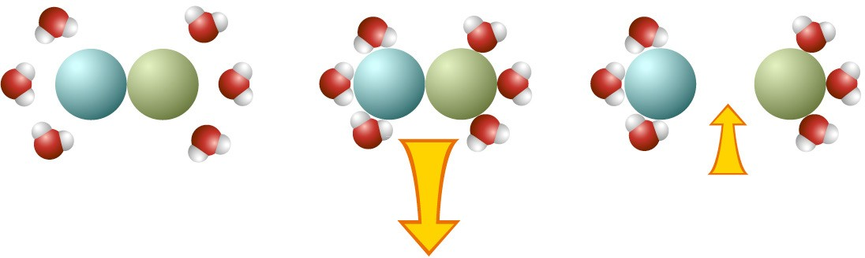
Energy released as water molecules “bond” to the solute.

Energy used when the solute is pulled apart.

Title: Exothermic.

How does the size of the arrows relate to the change in temperature of the solution?
The arrows show that more energy is released when the water molecule associate with the solute than is absorbed when the solute is pulled apart. This process is therefore exothermic.

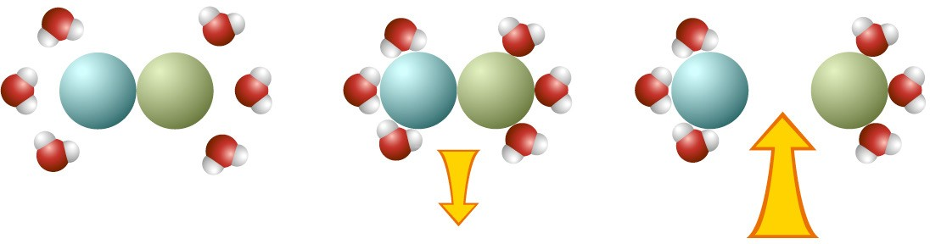
Energy released as water molecules “bond” to the solute.
Energy used when the solute is pulled apart.

Title: Endothermic.
How does the size of the arrows relate to the change in temperature of the solution?
The arrows show that more energy is required to pull the solute apart than is released when water associates with the solute. Because more energy is absorbed than is released, this process is endothermic.

TAKE IT FURTHER

- The hand warmer shown in the video heats up as molecules and ions come together to form a crystal. Does the process of making bonds to form a crystal use or release energy?
Energy is released when bonds are formed to create the crystal.

- If you think about the energy of making and breaking “bonds,” why do you think there is an increase in temperature when isopropyl alcohol dissolves in water?
There is an increase in energy when isopropyl alcohol is dissolved in water maybe because more energy is released when water associates with isopropyl alcohol molecules than is required to pull isopropyl alcohol molecules apart from one another.

