Test Bank - Chapter 6

The questions in the test bank cover the concepts from the lessons in Chapter 6. Select questions from any of the categories that match the content you covered with students. The types of questions include multiple choice, true/false, fill-in-the-blank, and short answer.

# Multiple Choice

1. A chemical change is different than a physical change because in a chemical change
   1. Chemicals are used
   2. Molecules do not physically touch
   3. A new substance is formed and in a physical change no new substance is formed
   4. The change can be seen, but in a physical change it cannot
2. In a chemical reaction
   1. The atoms of the reactants always stay together to form the products
   2. The atoms of the reactants unbond, rearrange, and then rebond to form the products
   3. New atoms are formed which combine to make the products
   4. Some atoms disappear while others multiply to form the products
3. In the chemical reaction CH4 + 2O2 → CO2 + 2H2O, there are reactants on the left of the equation and products on the right. If you count the atoms in the reactants, there are
   1. 4 carbon atoms, 4 hydrogen atoms, and 2 oxygen atoms
   2. 1 carbon atom, 4 hydrogen atoms, and 2 oxygen atoms
   3. 1 carbon atom, 4 hydrogen atoms, and 4 oxygen atoms
   4. 4 carbon atoms, 4 hydrogen atoms, and 4 oxygen atoms
4. In a chemical reaction, mass is conserved. This means that
   1. The molecules of the reactants do not change during a chemical reaction
   2. The mass of the products stays the same during a chemical reaction
   3. The type and number of atoms in the reactants equals the type and number of atoms in the products
   4. The mass of the products is always twice the mass of the reactants.
5. If the reactants on the left side of a chemical equation are C3H8 + 5O2, the products in a balanced equation could be
   1. 4CO2 + 3H2O
   2. 3CO2 + 4H2O
   3. 2CO2 + 3H2O
   4. 3CO + 4H2O
6. If more reactants are used in a chemical reaction, more products will be produced. This is because
   1. More reactants cause the reaction to heat up
   2. More reactants take up the same volume
   3. More reactants have more atoms to react to form more products
   4. Too many products can slow down the reaction
7. In a chemical reaction, Substance A reacts with Substance B and forms a new substance AB. The chemical equation for this reaction is A + B = AB. If you add more and more of only Substance A, there will be
   1. Less and less of product AB
   2. More and more of product AB with no limit to the amount of AB produced
   3. No change in the amount of AB produced
   4. More and more of product AB but limited by the amount of B
8. One clue of a chemical change is the formation of a precipitate. A precipitate is formed when
   1. Two liquids react and a gas is produced
   2. A solid dissolves in a liquid
   3. One liquid dissolves in another
   4. Two liquids react and a solid is formed
9. In a chemical reaction, if the reactants are heated, the reaction usually happens
   1. Faster
   2. Slower
   3. At the same rate
   4. In a smaller volume
10. Some chemical reactions require a substance called a *catalyst*. The main purpose of a catalyst is
    1. To warm up the reaction
    2. To speed up the reaction
    3. To create more reactants
    4. To stop the reaction
11. One characteristic property of a substance is the way it reacts chemically with another substance. Another way of saying this is that substances react chemically in characteristic ways. This means that
    1. A substance will always react the same way when tested with the same chemical
    2. A substance will always react differently when tested with the same chemical
    3. A substance will react in the same way when tested with two different substances
    4. The characteristic properties of a substance are always changing
12. If two substances react and the temperature of the mixture increases, the reaction is
    1. Endothermic
    2. Not one that produces anything new
    3. One that needs a catalyst
    4. Exothermic
13. If two substances react and the temperature of the mixture decreases, the reaction is
    1. Endothermic
    2. Never going to happen unless it is heated
    3. Exothermic
    4. one that causes atoms to be destroyed
14. If a reaction is exothermic,
    1. It takes more energy to break the bonds of the reactants than is released when the bonds in the products are formed
    2. More energy is released when the bonds in the products are formed than is used to break the bonds in the reactants
    3. The same amount of energy is used to break the bonds of the reactants as is released when the bonds in the products are formed
    4. The temperature goes down
15. If a reaction is endothermic,
    1. The temperature increases
    2. It takes more energy to break the bonds of the reactants than is released when the bonds in the products are formed
    3. More energy is released when the bonds in the products are formed than is used to break the bonds in the reactants
    4. The same amount of energy is used to break the bonds of the reactants as is released when the bonds in the products are formed
16. In water, there are always some water molecules which have become ions. These ions are produced by transferring a ___from one water molecule to another.
    1. Neutron
    2. Electron
    3. Proton
    4. Molecule
17. In any sample of water, there are always some water molecules which have become ions. These ions are
    1. H2O+ and OH-
    2. HO+ and H2O-
    3. H3O+ and OH-
    4. HO+ and HO-
18. When the pH of water is neutral, there is
    1. a higher concentration of OH- than H3O+
    2. an equal concentration of OH- and H3O+
    3. a higher concentration of H3O+ than OH-
    4. no OH- ions and no H3O+ ions
19. When the pH of a solution becomes more acidic, the number on the pH scale
    1. Decreases
    2. Increases
    3. Stays the same
    4. Doubles
20. When the pH of a solution becomes more basic, the number on the pH scale
    1. Decreases
    2. Increases
    3. Stays the same
    4. Triples
21. When the pH of a solution becomes more acidic, the concentration of H3O+ ions
    1. Decreases
    2. Increases
    3. Stays the same
    4. Doubles
22. When the pH of a solution becomes more basic, the concentration of H3O+ ions
    1. Decreases
    2. Increases
    3. Stays the same
    4. Triples
23. If a solution is acidic, it can be neutralized by adding
    1. A stronger acid
    2. Heat
    3. A base
    4. A weaker acid
24. If a solution is basic, it can be neutralized by adding
    1. An acid
    2. A weaker base
    3. More base
    4. A colder base
25. When carbon dioxide (CO2) gas reacts with water
    1. A strong base is produced
    2. The carbon and oxygen atoms disappear
    3. An acid is produced
    4. More carbon and oxygen atoms are produced

Chapter 6

Multiple Choice Answers

|  |  |
| --- | --- |
| 1. c 2. b 3. c 4. c 5. b 6. c 7. d 8. d 9. a 10. b 11. a 12. d 13. a | 1. b 2. b 3. c 4. c 5. b 6. a 7. b 8. b 9. a 10. c 11. a 12. c |

# True/False and Fill-in-the-blank

*True or false?*

Dissolving salt is a chemical reaction. False

In a chemical reaction, only the atoms present in the _______can end up in the products. reactants

In a chemical reaction, no new atoms are created, and no atoms are _______. destroyed

Increasing the amount of reactants may increase the amount of __. products

What is the term for a solid that is formed by mixing together two solutions? Precipitate

*True or false?*

A catalyst slows down the rate of reaction to make better products. False

*True or false?*

Products in a chemical reaction are usually formed more quickly at higher temperatures. True

A catalyst does not actually become part of the of a chemical reaction. products

*True or false?*

Because substances react chemically in characteristic ways, you can use the way they react to identify an unknown. True

It takes to break bonds, and __is released when bonds are formed. energy, energy

If it takes more energy to break the bonds of the reactants than is released when the bonds of the products are formed, the reaction is _________. endothermic

If more energy is released when the bonds of the products are formed than it takes to break the bonds of the reactants, the reaction is ___________. exothermic

*True or false?*

Two molecules are more likely to react if they have more energy when the collide. True

The _____ and of atoms are the same on both sides of a chemical equation. type, number

*True or false?*

In a combustion reaction, matter is destroyed. False

# Short Answer

What is the main difference between a chemical and a physical change?

In a chemical change, the bonds between atoms in reactants break and the atoms rearrange and form new bonds to make different substances. In a physical change, the identity of the substances does not change and no new substances are formed.

What does it mean to say that “atoms are not created or destroyed” in a chemical reaction?

This means that in a chemical reaction, the atoms in the reactants are the only atoms that can end up in the products. All the different types and numbers of atoms in the reactants end up in the products.

In a chemical reaction, is it possible to change the amount of products by changing the amount of reactants? Why?

You can change the amount of products by changing the amount of reactants because the products are made from the reactants. If you add more reactants, more products will be produced. If you add less reactant, less product will be produced. If you keep adding more and more of just one reactant, you may get more product if you have enough of the other reactant. But eventually, the other reactant will run out, so adding more of just one reactant will not guarantee that more products will be produced.

Can atoms that are not in the reactants end up in the products of a chemical reaction? Why or why not?

Atoms that are not in the reactants cannot end up in the products because the products are made up of only the atoms of the reactants.

In this chemical reaction between methane (CH4) and oxygen gas (O2), the products carbon dioxide (CO2) and water (H2O) are formed. Explain what happens during a chemical reaction that causes the atoms in the reactants to end up in the products.

**CH4**

methane

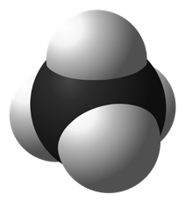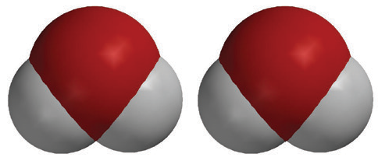

**2O2**

oxygen

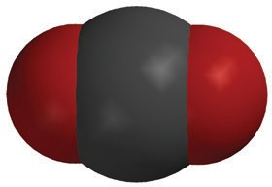

**CO2**

carbon dioxide

**2H2O**

water

+

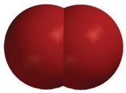

+



The reactants interact and the atoms of the reactants unbond, rearrange and rebond in different ways to form the products.

How do you know that this chemical equation is balanced?

The equation is balanced because there is the same type and number of atoms in the reactants as in the products. There is 1 carbon, 4 hydrogen, and 4 oxygen atoms on both sides of the equation.

When you combine vinegar and baking soda, a gas is produced. Why is the gas considered evidence that a chemical reaction occurred?

Since a gas was produced where there wasn’t one before, it is a new substance. When a new substance is formed, that is a clue that a chemical change has occurred.

In the vinegar and baking soda reaction, can you continue to add more and more of one reactant and expect to get more and more product? Why or why not?

If you add more baking soda, you may get more carbon dioxide produced if there is enough vinegar to react with the extra baking soda. But if you keep adding more and more baking soda, the vinegar will get used up and no more reaction will take place and no more products will be produced.

Imagine that you have two substances A and B and that A reacts with B. If you have a very large sample of A, and another very small sample of A, will both react with substance B?

The large and small samples of A should both react with B. A chemical reaction between substances is a characteristic property of the substance and shouldn’t depend on the amount.

When you combine calcium chloride solution with baking soda solution, a precipitate is formed. Why is the precipitate considered evidence that a chemical reaction occurred?

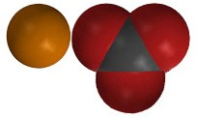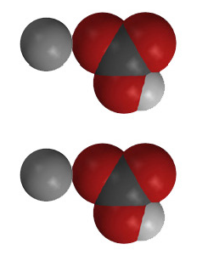

+

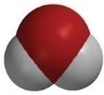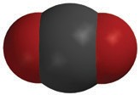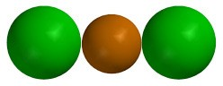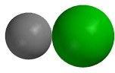

+

+

+

**CaCl2**

calcium chloride

**2NaHCO3**

sodium bicarbonate

**CaCO3**

calcium carbonate

**2NaCl**

sodium chloride

**H2O**

water

**CO2**

carbon dioxide

Since two liquids were combined and a solid precipitate is produced, the solid is a new substance. When a new substance is formed, that is a clue that a chemical reaction has taken place.

Is this a balanced chemical equation? Explain how you know.

Yes, this equation is balanced. You can tell because the same type and number of atoms are on the left side of the equation as on the right.

Let’s say that you are studying a chemical reaction between two substances, A and B. Describe how you would set up an experiment to find out whether the speed (rate) of the reaction between these substances was affected by temperature.

I would make two sets of reactants as similar to each other as possible. I would heat one set of reactants and cool the other set. I would mix the two heated reactants together in one container and the two cooled reactants together in a separate container at the same time. Depending on which reacted faster, I would know whether temperature affected the rate of the reaction.

A glowstick works when two chemicals in the glowstick mix and have a chemical reaction that produces certain products and light. Explain, on the molecular level, why a warm glowstick glows brighter than a cold glowstick.

If the glowstick is warmed, the molecules of the reactants are moving faster. If molecules are moving faster, more molecules are moving fast enough to react so the rate of the reaction is faster. If more molecules are reacting, more products are produced and the light will be brighter.

Would lowering the temperature of the reactants affect the rate of a chemical reaction? Why?

Lowering the temperature would probably slow down the rate of the reaction. Reactants have to collide with each other with enough energy to start the reaction. Cooling them would slow them down so fewer would react.

What is a catalyst?

A catalyst is a substance that makes a chemical reaction happen faster. A catalyst does not become part of the products of the reaction.

Hydrogen peroxide (H2O2) decomposes (reacts with itself and splits apart) to become oxygen gas (O2) and water (H2O). Hydrogen peroxide does this at a very slow rate but the speed can be increased by adding a catalyst. Describe an experiment you could do to test whether catalyst A or Catalyst B made the decomposition of hydrogen peroxide happen faster.

I would measure the same amount of hydrogen peroxide in two identical containers. I would be sure that the temperature of the two samples was the same. I would then add the same amount of Catalyst A and Catalyst B to the samples at the same time. The one in which the bubbling happened the fastest was decomposing faster.

Is this a balanced chemical equation? Explain how you know.

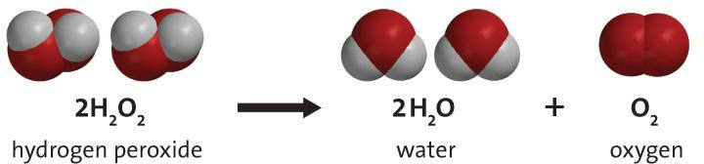

Yes, the equation is balanced. There are 4 oxygen atoms and 4 hydrogen atoms on the left side (reactants) and the right side (products).

One important concept in chemistry is that substances react in characteristic ways. This means that a substance will react with another in a certain way to produce particular products and it will do this every time the two substances react. Explain, on the molecular level, why substances react in characteristic ways.

Substances are made up of a certain type and number of atoms bonded together in a certain way. Every substance is unique in these ways. So when two substances react, their atoms will interact according to these characteristics and they should do it the same way each time.

Your teacher added universal indicator solution to substances in two separate cups. The indicator turned a different color in each cup. Use what you know about chemical reactions to explain how you know that the substances in the two cups must have been different.

Substances react chemically in characteristic ways. If a test liquid reacts with a sample of a substance and changes color, that is the characteristic way these substances react. If the same test liquid reacts with another sample of a substance and changes to a different color, that is the characteristic way that these substances react. This means that the two substances must be different.

You tested different substances with test liquids to try to figure out the identity of an unknown substance. When testing the different powders with a particular test liquid, why was it important to put the same amount of liquid on each different powder?

We were trying to compare the results of putting liquids on known powders with putting these same liquids on an unknown powder. If we put a lot of liquid on a known powder and only 1 drop on the unknown, the results would not be as easy to compare. It is best to use the same amount on both so that it is a fair test and easier to compare the results.

Explain, in terms of making and breaking bonds, what it means for a reaction to be *endothermic*.

In a chemical reaction, it takes energy to break the bonds between the atoms of the reactants. Energy is released when these atoms bond to form the products. If it takes more energy to break the bonds of the reactants than is released when the bonds of the products are formed, then the reaction is endothermic.

Explain, in terms of making and breaking bonds, what it means for a reaction to be *exothermic*.

In a chemical reaction, it takes energy to break the bonds between the atoms of the reactants. Energy is released when these atoms bond to form the products. If more energy is released when the bonds of the products form than it took to break the bonds of the reactants, the reaction is exothermic.

In a chemical reaction, it takes energy to break the bonds between the atoms of the reactants. Energy is released when these atoms bond to form the products.

1. 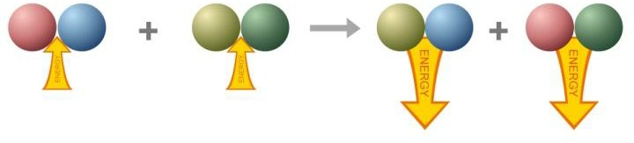Use the size and direction of the “energy arrows” to explain whether this illustration is an exothermic or endothermic reaction.

This is an exothermic reaction. The arrows show that there is more energy released when the bonds in the products are formed than was used to break the bonds of the reactants.

1. 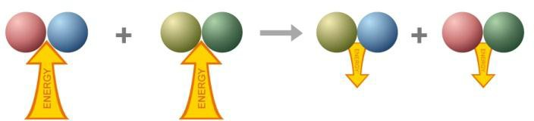Use the size and direction of the “energy arrows” to explain whether this illustration is an exothermic or endothermic reaction.

This is an endothermic reaction. The arrows show that it took more energy to break the bonds of the reactants than was released when the bonds in the products were formed.

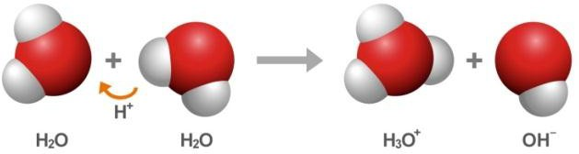When two water molecules come together, it is possible for a proton from a hydrogen atom in one water molecule to bond to the oxygen atom in the other. Explain why the water molecule that gained the proton is called H3O+ and the molecule that lost the proton is called OH-.

The water molecule that gained the proton now has one more proton than electrons so it is actually a positively charged ion. Gaining a proton is like gaining a hydrogen atom but without the electron. So the ion is H3O+ instead of H2O+. The water molecule that lost the proton now has one more electron than proton so it is a negatively charged ion. Losing a proton is like losing a hydrogen atom so this ion is OH- instead of H2O-.

If you put a drop of citric acid solution into green universal indicator, it will become acidic and be either yellow, orange, or red on the universal pH color chart. Explain why adding a base like sodium carbonate solution could neutralize the solution and make it green again.

The acidic solution has a greater concentration of H3O+ ions than OH- ions. When a base is added, it accepts protons from water molecules, creating more OH- ions. The H3O+ ions and indicator molecules donate protons to the OH- ions. This lowers the concentration of H3O+ ions toward neutral and changes the color of the indicator.

Dry ice is solid carbon dioxide. Unless it is kept very cold, dry ice will quickly change from a solid to carbon dioxide gas. Do you think placing a piece of dry ice in room temperature water will make the water become acidic, basic, or will the water stay neutral? Explain your answer.

The carbon dioxide will make the water acidic. Placing dry ice in room temperature water will cause the dry ice to become carbon dioxide gas. When carbon dioxide dissolves in water, some of the carbon dioxide reacts with the water and forms carbonic acid. Carbon dioxide from your breath or any source can react with water to make it acidic.

Carbon dioxide from different sources can react with water to form carbonic acid. Why do you think that carbon dioxide from different sources can cause the same reaction with water?

Carbon dioxide and water have certain chemical characteristics. They should react the same way no matter where the carbon dioxide comes from.

An Alka Seltzer tablet has sodium bicarbonate (baking soda) and citric acid in it. What do you think happens if you put an Alka Seltzer tablet in universal indicator solution?

Depending on how much or how strong the acid and base are, the indicator solution might change toward the acid colors or the base colors. It might also become a neutral green color if the acid and base neutralize each other.