Activity Sheet Name Chapter 6, Lesson 12
Natural Resources & Synthetic Materials Date

- Both natural products and synthetic products come from natural resources. Explain why this statement is true.

- What does it mean if a product is “synthetic”?

- Some synthetic substances are exactly the same as substances found in nature. Why would scientists synthesize something that already exists?
HINT: YouTube Video, “Professor Dave Explains: Will Synthetic Vitamins Make Me Explode?”

- Which synthetic product will you do research on?

Use these questions to guide your research about your synthetic product.

- What natural resources are used to make the synthetic product?
- What chemical processes are used to make the synthetic product?
- What are the impacts to society of making and using the synthetic product, compared to making a more natural product with a similar function?

Before starting your research, you will conduct a hands-on activity where you create a synthetic product—a gel worm. The three questions above will guide the activity and will model how to approach your research.

WHAT NATURAL RESOURCES ARE USED TO MAKE THE SYNTHETIC PRODUCT?
The reactants in the chemical synthesis you will do are sodium alginate and calcium chloride.
Natural resources used to make the gel worm
 | Sodium Alginate | Calcium Chloride
What natural resource is this chemical made from? | A brown seaweed called kelp | Calcium chloride is made from limestone which is a common rock that is mined.
How is the natural resource processed to make this chemical? | The seaweed is cut up, mixed with water and filtered. The water evaporates off and the sodium alginate powder is left | The limestone is reacted with hydrochloric acid or sodium chloride to make calcium chloride.

ACTIVITY

Question to investigate
Why is a gel worm made from calcium chloride and sodium alginate solutions considered a synthetic product?

Materials
  - Calcium chloride solution in a small wide cup
  - Sodium alginate solution in a small wide cup
  - One dropper
  - Paper towels

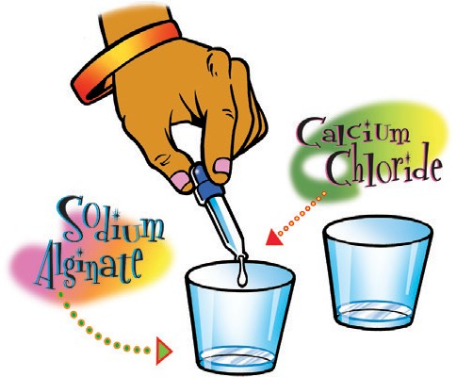
Procedure
- Use a plastic dropper to add about 10 drops of calcium chloride solution to the center of a cup containing 15 mL of sodium alginate solution.
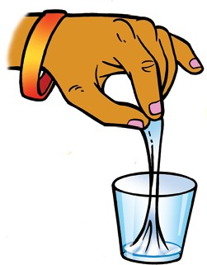
- Reach into the center of the solution (where you put the calcium chloride) and gently and slowly pull out the gel “worm.”
- Set the “worm” on a paper towel.

5. What were the calcium chloride and sodium alginate solutions like before you added the calcium chloride solution to the sodium alginate solution?

6. After you added the calcium chloride solution to the sodium alginate solution and began pulling from the center, how did the solutions change?

7. Why is the gel worm considered to be a synthetic product?

EXPLAIN IT WITH ATOMS & MOLECULES

What chemical processes are used to make the synthetic product?
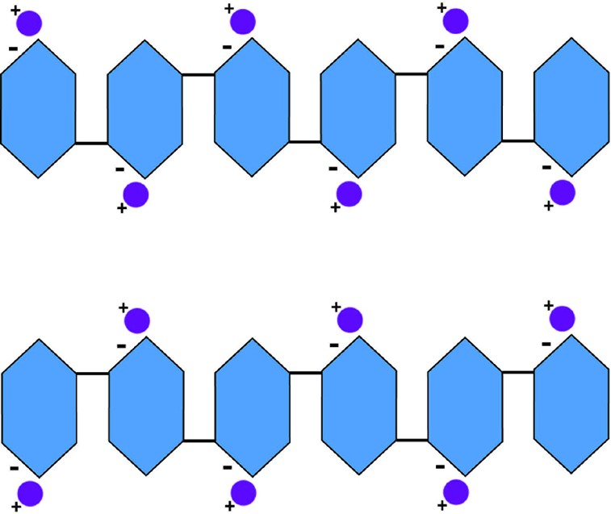
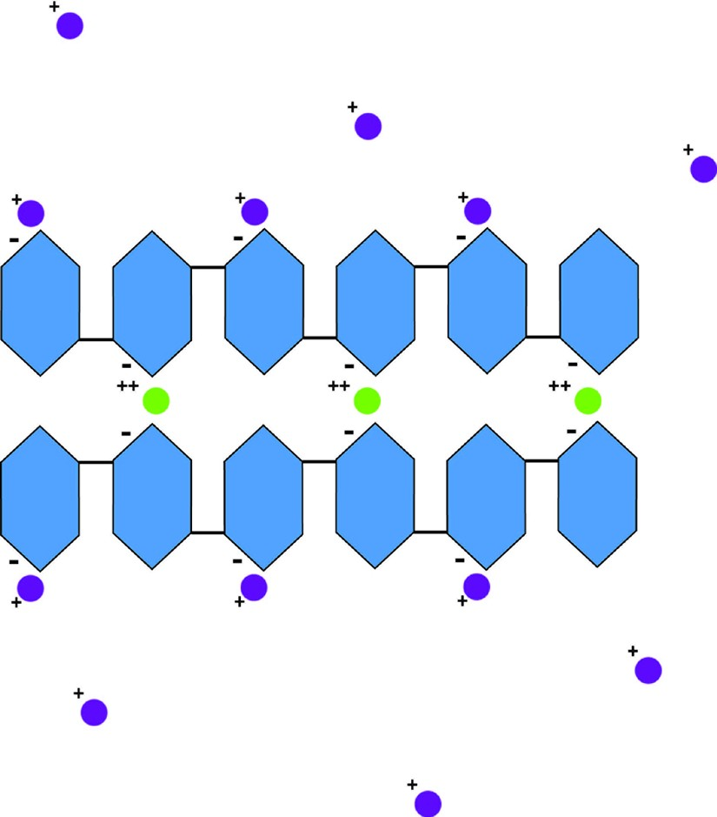
Adding the calcium chloride solution to the sodium alginate solution caused the sodium alginate to become a stiffer gel.
Two sodium alginate polymer chains

After adding calcium chloride

8. Describe what the calcium ions from the calcium chloride do to help make the sodium alginate polymer become a gel.

TAKE IT FURTHER

What are the impacts to society of making and using the synthetic product, compared to making a more natural product with a similar function?

9. Are the natural resources used to make the synthetic gel worm renewable or nonrenewable?
Fill out the chart below to answer the question.
Renewable and Nonrenewable Natural Resources Used to Make Each Snack
 | Main ingredients | Natural resources  used to make each | Renewable?  Why or why not?
Gel worm | Sodium alginate
 | Calcium chloride
Fresh fruit slices | Fruit

10. If gel worms were made and sold on a large scale as a synthetic snack item for kids, what are some of the impacts to society of producing and using them compared to producing and using fresh fruit slices?
Fill out the chart below to answer the question.

Impacts to society and the environment
 | Synthetic gel worm | Fresh fruit slices
Impact of harvesting, mining, or collecting the natural resources
Processing the natural resources to make the final product?
Usefulness of the product?

11. Which do you think is better, the gel worm snack or fresh fruit slices?
Why do you think so?

