Activity Sheet Name Chapter 6, Lesson 6
Using Chemical Change to Identify an Unknown Date

DEMONSTRATION
- Your teacher poured iodine solution on top of two white powders. How do you know that these two similar-looking powders are actually different?

- Adding iodine solution to one powder caused a physical change, while adding the iodine solution to the other powder caused a chemical change. Which powder probably reacted chemically with the iodine solution?
How do you know?

ACTIVITY

Question to Investigate
Can you use the characteristic ways substances react to tell similar-looking substances apart?

Materials for Each Group
- Baking soda in cup
- Baking powder in cup
- Cream of tartar in cup
- Cornstarch in cup
- Water in cup
- Vinegar in cup
- Tincture of iodine solution in cup
- Universal indicator solution in cup
- 4 Popsicle sticks
- Testing chart, either laminated or with a piece of wax paper over it
- 4 droppers

Procedure
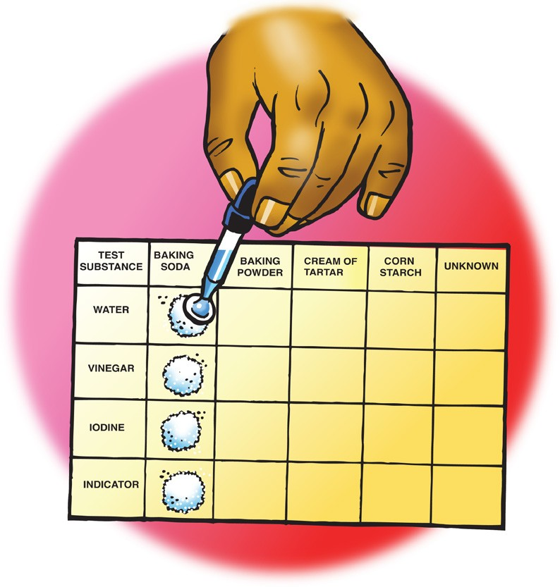
  - Use the end of a Popsicle stick to place four equal piles of baking soda on the testing chart in the baking soda column.
Do not use up all the powder at this time. You will need some of each powder for the last part of the experiment.
  - Add 5 drops of water to the first pile of baking soda. Record your observations in the chart on the activity sheet.
  - Continue testing each pile of baking soda with a different test solution and recording your observations.
  - Test each of the powders with the test solutions the way you tested baking soda and record your observations.

Question to Investigate
Can you use the characteristic ways substances react to identify an unknown powder?

Materials for Each Group
    - Unknown in cup
    - 1 Popsicle stick
    - Testing sheet
    - 4 test solutions
    - 4 droppers

Procedure
- Place four samples of your group’s unknown powder in the “Unknown” column on the testing chart on the next page.
- Test the unknown with each test solution in the same way you tested each of the other powders.
- Compare the set of reactions for the unknown with those of the other powders.

Test solutions | Unknown
Water
Vinegar
Iodine solution
Indicator solution

- What is the identity of the unknown?
Which observations led you to your conclusion?

EXPLAIN IT WITH ATOMS & MOLECULES
- On the molecular level, why did the different substances react in a characteristic way with the test solutions?

TAKE IT FURTHER
Baking powder is a combination of different powders—baking soda, cream of tartar, and cornstarch. Two of these three powders react with one another and produce carbon dioxide gas when water is added.

Question to Investigate
Which two substances in baking powder react with one another and produce a gas when water is added?

Materials for Each Group
  - Baking soda in a cup
  - Cornstarch in a cup
  - Cream of tartar in a cup
  - 3 Popsicle sticks
  - Toothpicks
  - Wax paper
  - Water
  - Dropper

Procedure
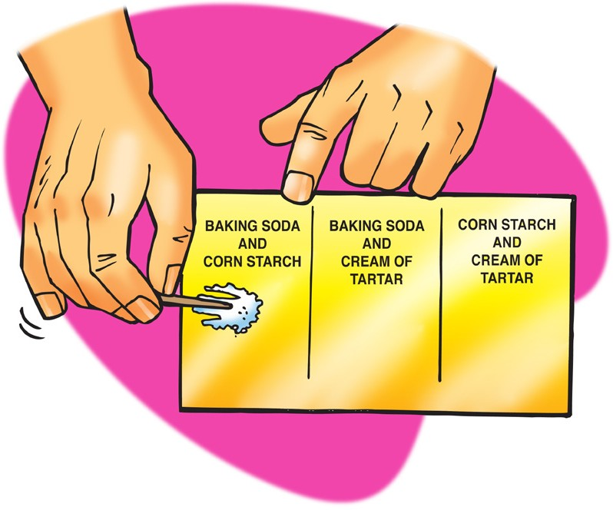
- Use separate popsicle sticks to place a small amount of two powders on a piece of wax paper.
- Use a toothpick to mix the powders.
- Use a dropper to add about 5 drops of water to the combined powders and record your observations.
- Repeat Steps 1 and 2 until you have tested all three combinations.
Baking soda + cornstarch | Baking soda + cream of tartar | Cornstarch + cream of tartar

- Which two powders react to produce carbon dioxide gas when water is added to baking powder?

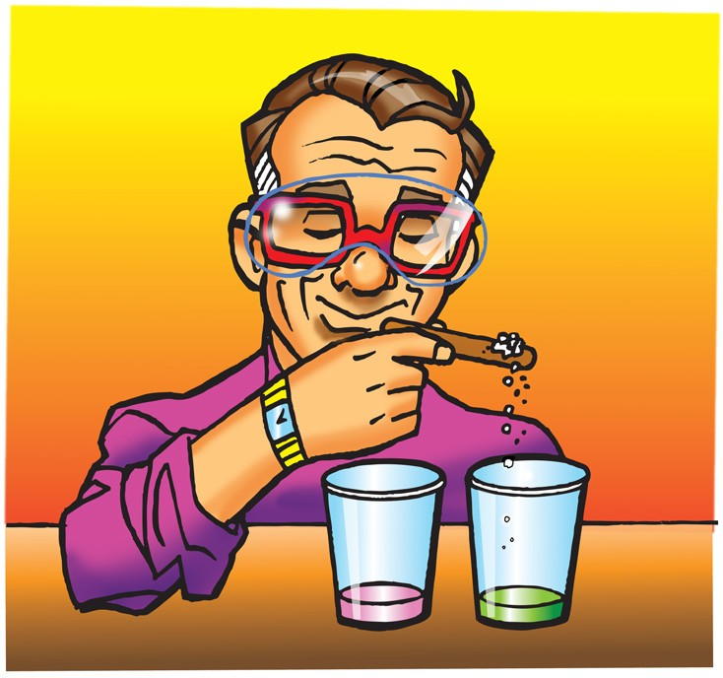
DEMONSTRATION
Your teacher did a demonstration comparing the way vinegar and cream of tartar react with indicator solution.
- Based on your observations, and what you know about vinegar and cream of tartar, why do you think the baking soda and cream of tartar reaction is similar to the baking soda and vinegar reaction?

Testing Chart

Test solutions | Baking Soda | Baking Powder | Cream of tartar | Cornstarch | Unknown
Water
Vinegar
Iodine
Indicator

Results Table

Test solutions | Baking Soda | Baking Powder | Cream of tartar | Cornstarch | Unknown
Water

Vinegar
Iodine
Indicator

