**Activity Sheet Name Chapter 6, Lesson 7**

**Energy Changes in Chemical Reactions Date**

# ACTIVITY

## Question to Investigate

Does the temperature increase, decrease, or stay the same in the reaction between baking soda and vinegar?

## Materials

* Vinegar in a cup
* Baking soda in a cup
* Thermometer

## Procedure

1. Place a thermometer in the vinegar. Read the thermometer and record the temperature on the activity sheet.
2. While the thermometer is in the cup, add all the baking soda from your cup.
3. Watch the thermometer to observe any change in temperature. Record the temperature after it has stopped changing.
4. **Did the temperature increase, decrease, or stay the same when you combined baking soda and vinegar?**
5. **What is the lowest temperature reached during your group’s reaction?**

## Question to Investigate

Does the temperature increase, decrease, or stay the same in the reaction between baking soda solution and calcium chloride?

## Materials

* + Baking soda solution in a cup
  + Calcium chloride in a cup
  + Thermometer

## Procedure

1. Place a thermometer in the baking soda solution. Read the thermometer and record the temperature on the activity sheet.
2. While the thermometer is in the cup, add all the calcium chloride from the cup.
3. Watch the thermometer to observe any change in temperature. Record the temperature when it stops changing.
4. **Did the temperature increase, decrease, or stay the same when you combined baking soda solution and calcium chloride?**
5. **What is the highest temperature reached during your group’s reaction?**

# EXPLAIN IT WITH ATOMS & MOLECULES

When the temperature of a chemical reaction decreases, the reaction is called an *endothermic* reaction. When the temperature of a chemical reaction increases, the reaction is called an *exothermic* reaction.

**Vinegar and baking soda reaction**

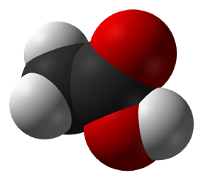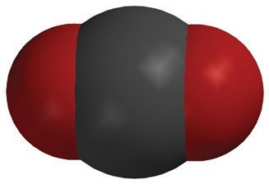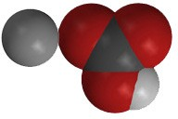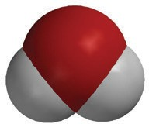

+

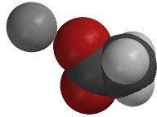

+

+

**C2H4O2**

acetic acid

**NaHCO3**

sodium bicarbonate

**NaC2H3O2**

sodium acetate

**H2O**

water

**CO2**

carbon dioxide

1. **Is this an endothermic or exothermic reaction? _____________________**
2. **Draw an energy arrow on the reactant side and another on the product side to compare the amount of energy used and released during the reaction.**
3. **What do the arrows show about the amount of energy required to break the bonds of the reactants compared to the amount of energy released when the products are formed?**

**Baking soda solution and calcium chloride reaction**

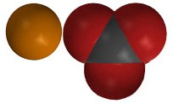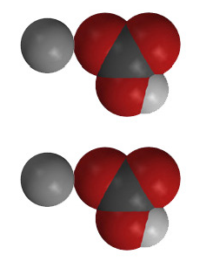

+

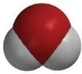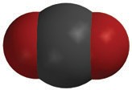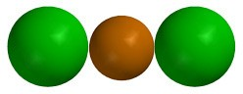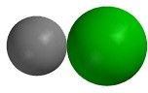

+

+

+

**CaCl2**

calcium chloride

**2NaHCO3**

sodium bicarbonate

**CaCO3**

calcium carbonate

**2NaCl**

sodium chloride

**H2O**

water

**CO2**

carbon dioxide

1. **Is this an endothermic or exothermic reaction? _______________________**
2. **Draw an energy arrow on the reactant side and another on the product side to compare the amount of energy used and released during the reaction.**
3. **What do the arrows show about the amount of energy required to break the bonds of the reactants compared to the amount of energy released when the products were formed?**

# TAKE IT FURTHER

Disposable hand warmers and self-inflating balloons use different chemical reactions to make them work. Both are packaged so that the reactants are kept separate. Once the consumer causes the reactants to combine, the chemical reactions begin.

## Question to Investigate

How can endothermic and exothermic chemical reactions be useful?

## Materials for Each Group

* + Disposable self-heating hand warmer
  + Self-inflating balloon

## Procedure

1. Open the package the hand warmer is in to begin the chemical reaction.
2. Shake the hand warmer and feel for any temperature change.
3. Activate the self-inflating balloon by either pressing down or stepping on the packet of citric acid to rupture it.
4. Shake the balloon and feel the area on the balloon where the liquid is.
5. Be sure everyone in your group has a chance to feel both the hand-warmer and the self-inflating balloon.
6. **Which is an example of an endothermic reaction?**

**Which is an example of an exothermic reaction?**

1. **For the hand warmer, what can you say about the amount of energy required to break bonds in the reactants compared to the amount of energy that is released when bonds are formed in the products?**
2. **For the self-inflating balloon, what can you say about the amount of energy required to break bonds in the reactants compared to the amount of energy that is released when bonds are formed in the products?**

# EXTRA EXTEND

## Question to investigate

What clues do you observe that a chemical reaction is taking place?

## Materials for each group

* + Magnesium sulfate solution in cup
  + Sodium carbonate solution in cup
  + Citric acid solution in cup
  + Universal indicator
  + Thermometer
  + 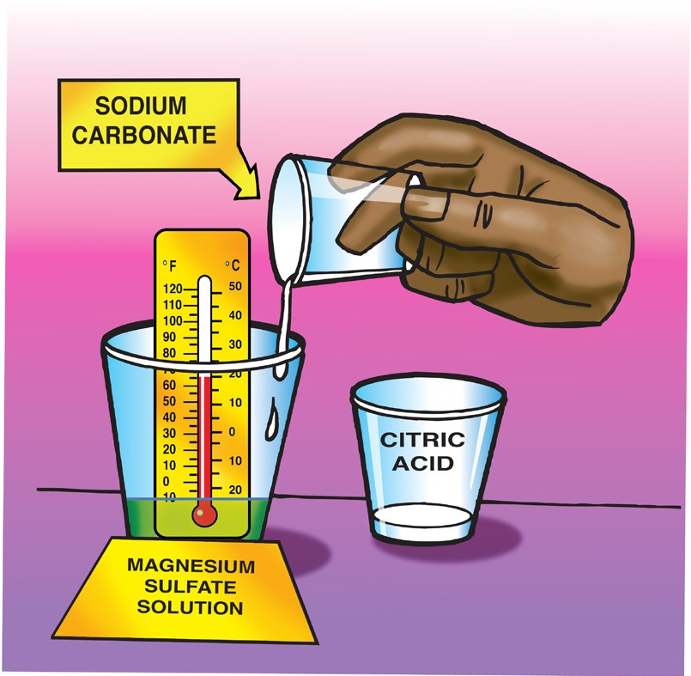Dropper

## Procedure

1. Add 5 drops of universal indicator to the magnesium sulfate solution.
2. Place a thermometer in the cup and record the temperature of the solution.
3. Add 10 mL of sodium carbonate solution.
4. Add 10 mL of citric acid.
5. **What clues do you observe that let you know that a chemical reaction is taking place?**
6. **In this chemical reaction, you may not have noticed a temperature change. Use what you know about energy in the breaking and making of bonds to explain how this can be.**